Making the Most of Your Library

Module 1: The Reader Experience
Making the most of your library.

The promotion of ‘Reading for Pleasure’ starts with your readers. It’s all about your library giving your customers a satisfying experience and one they will want to return to again and again. Your library is a community space that offers your customers a place to share their reading choices and find new ones.
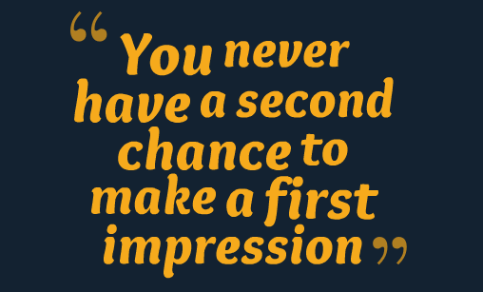

First impressions are nearly always lasting impressions.

- Your customers should get a positive, warm and friendly message from you when they enter your building and your customers’ passion for books and reading should be supported.
- Attractive shelves and displays will encourage more visitors and customers back to your library.
- Most customers choose books by browsing; a pleasurable library visit spent browsing even for a few minutes encourages borrowing. Shelves that are not crammed full of books allow for this. If customers can’t find what they’re looking for very easily they may well go home empty-handed.
- Reader recommendations, promotions and talking about reading increases confidence in choosing different authors. Even the temptation to try something new adds up to giving customers a satisfying experience and increases reading for pleasure.

At Silverdale they rearranged their library after completing to provide more space for events in the library the stock was rearranged to make it more easily accessible and create space to enable more face on display. Following the reorganisation a customer commented, “It’s lovely in here, nice and bright and lots of space”.

Silverdale Library before the stock/ layout reorganisation

Silverdale library following the stock reorganisation

1. The Customer experience. (What’s your library like for your customers?)
Think about what your customers expect from your library. Is it inviting? Is the entrance untidy, are there any out of date notices? Is it obvious where to look for a book? Regular customers will know where their favourite books are, but may get stuck in a rut. Is there anything new to encourage them to try something different? Do your signs work? Visitors or new customers may struggle to find what they want without asking:
What could you do so your customers could get more out of their visit?

Think about the questions below and write down a few ideas
• What do you like best in this library?
• How does it make you feel?
• Why do you want to volunteer in this library?
Task or Group Activity

Library walkabout.
Pretend you’re a first-time visitor. Step outside and look at your library as if for the first time and ask yourself a few questions.
- Look at the signage. Can you see the signs from the road? Will they attract passers-by or new people to the area?
- What can you do to attract more people?
- How close do you have to get to your library to see the opening hours, -are they visible?
- What could be done to make the entrance more welcoming?
- Look at the notices: Are there too many? Are they up-to-date? Are they tatty? Are they well organised?

Now go inside.
- What do you see first?
- Do the first few steps into the library invite you to walk further and look around?
- How long is it before you see a book or do you see shelves first?
- Is it clearly signed?
- If you were looking for the crime section would it be easy to find?
- Is the children’s area inviting? Is there somewhere for parents/carers to sit and read to their child?
- What about displays? Have they been changed recently?
- Go to the back of the library and look towards the entrance. Does it look attractive from a different position?

Lots of questions, but just jot down a few observations and make a note of anything you think you can improve. A simple walk around your library to look at the area through the eyes of a new customer is one of the best ways to keep your library fresh. Your regular customers will know where their favourite section is, but even a different display may encourage them to read something new. A new customer may feel awkward and not like to ask where anything is and if they don’t find what they want may leave empty handed.

