Making the Most of Your Library

Module 3: Maintaining Good Stock
Maintaining Good Stock

The books in your library need to be in good condition, up-to-date and suitable for lending. Editing, or weeding as it’s sometimes called, is an essential task. There are exceptions; local history books may be old and not in particularly good condition, but are still worthy of having a place on the shelves in the appropriate Local History area. You need to decide what’s right for your library as well as paying attention to suggestions from your librarians

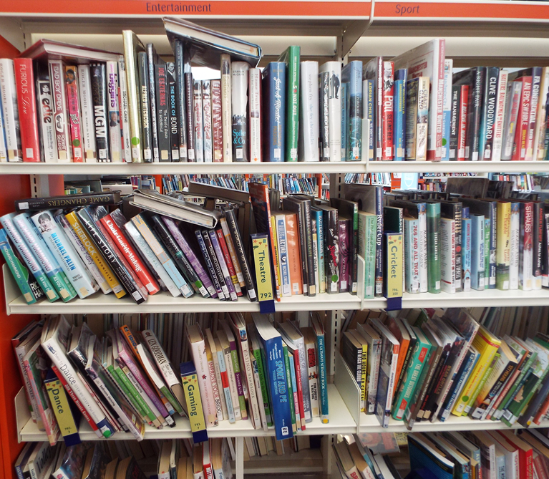
Untidy shelves look unappealing

Book shelves need to be attractive, inviting and easy to use.

All books, with the exception of local history books, have a shelf life. It’s sometimes tempting to hold on to older books especially if they’re on your favourites list; but shelves full of grubby books and books in poor condition are not as appealing. Customers are less likely to browse and ultimately borrow anything.

Tightly packed shelves are damaging for the books, and are also unappealing. If a book is not easy to take off the shelf without pulling off the ones either side of it, then it’s unlikely to be borrowed by your customers. The general recommendation is that the shelves are only ever about two-thirds full.

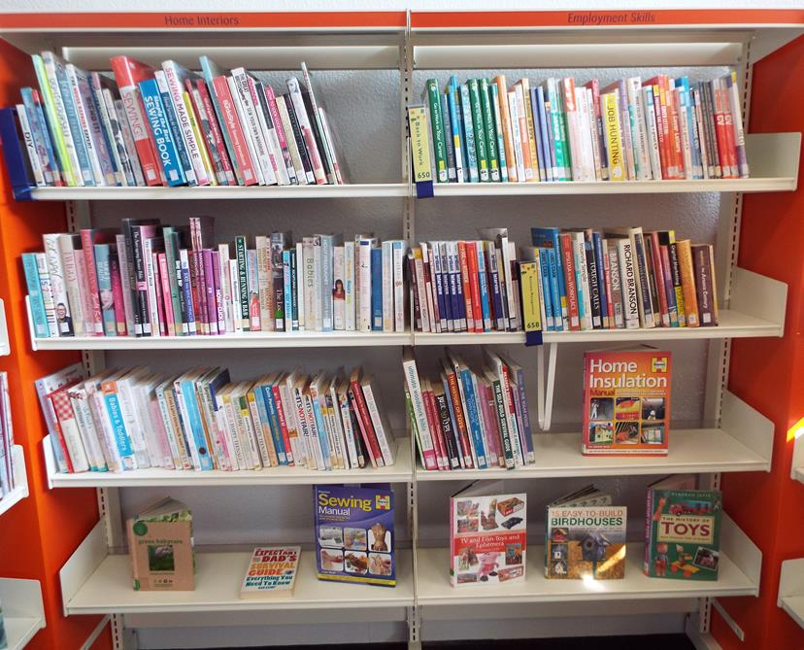
Tidy shelves can be used as display shelves

Shelves that look uncluttered and have good quality books on them empty the fastest. The ‘less is more’ approach can encourage customers to borrow books because they can find what they want.

Everybody has a role to play keeping the book shelves and displays up to date and in good functioning order. Weeding and maintaining of displays can be done as you re-shelve returned books or put out newly arrived ones. As you go round your library shelves, look out for grubby or out of date items and remove them.

What to look for:
- Bindings that are shabby and coming undone
- Missing pages or pages that are dog-eared, torn, loose, yellowed or stained
- Loose, unattached or missing photographs
- Faded, scruffy, or dirty dust jackets or covers
- Damaged or bent spines or spine labels that are unreadable
- Water damage
- An unpleasant odour
- Hand-written notes and comments

Worn out paperbacks

Worn out hardbacks

Scruffy dust Jackets

‘Spoken word’ or ‘talking books’ can be identified in a similar way:
- Stained, discoloured, faded or dirty cases
- Split, cracked, tatty or broken cases
- Cases that have come apart in the middle
- yellowed or dirty labels on the cases or discs
- Missing or scratched discs

Books with out of date content will be non-fiction books, and may still be being borrowed by your customers if they need to know about a subject. But you run the risk of giving them inaccurate information. As a general rule subject areas that need to be kept up to date with current information are:
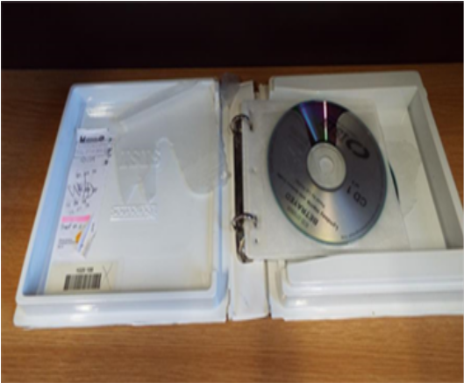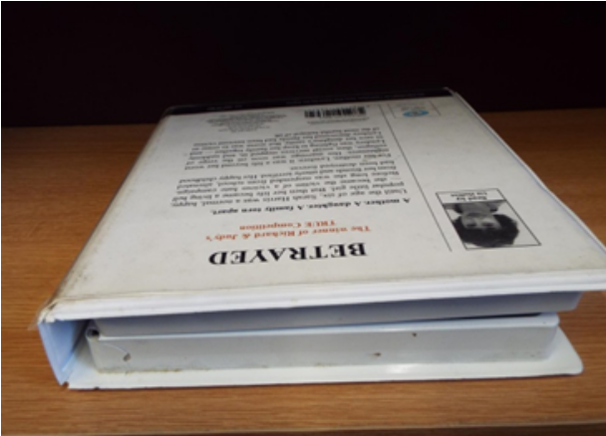
Dust can also make these cases look grubby. By just giving the cases a clean may well increase the probability of them being borrowed.
- Travel guides over 3-5 years old
- Business books over 3-5 years old
- Law books over 3-5 years old
- Computer books on older software
- Health books where new developments in medical treatments have made them out of date (over 5 years old)
- Study revision guides – if over 3 years old check if they are the latest edition.

Check with your local library service.

You may well come across a book that has not issued/ been on loan for twelve months. Resist the temptation to remove it.

Consider what you should do with it first:
- How old is it?
- Is it more than five years old and out of date?
- Has it not issued because it’s been read by most of your customers, no longer in demand or of current interest?
- Is it grubby or tatty?
- Should it be removed and withdrawn or discarded?
Or
- Does it still have a shelf life?
- Will it issue if it’s displayed forward facing or on a display?

Remember you still need a good selection of books for your customers, so aim not to over weed all in one go. It needs to be an ongoing process. Rearrange your shelves as you go along to include some front facing/ face on books.
Check: You may have a policy in your library about who makes the final decision to remove a book.

Task

Set yourself a challenge. Put some books that haven’t been out recently that you think your customers might like if they saw them on a display, or stand them face on at the end of a shelf and see if any of them go out.
Customers will often pick up a book on impulse when they’re browsing

Task or Group Activity

Put together a front facing/face on display of books that you think would be good for impulse borrowing. Choose books with similar genres, or subjects that are popular with your customers. You do not have to have read the book, just use the cover and the blurb on the back as a guide. Use a front facing/face on display shelf or the end of a shelf of books after you’ve weeded.

Note: For simplicity and consistency the word ‘books’ is used to cover all areas of stock: Adult Fiction, Adult non-fiction, Junior fiction, Junior non-fiction, Talking Books/Spoken Word and Digital formats.

