t
Version / date

Text here.

Annual Seminar 2021

Libraries: An essential part of local recovery
Version 1 / 06/07/2021

#LCSeminar2021

Contents

Programme | 4
Breakout Sessions | 6
Speaker biographies | 8
Sponsors | 13
Libraries Connected awards | 16
Award sponsors | 17
About Libraries Connected | 18
Venue | 19

Seminar programme 2021

Tuesday 19 October
9.00 – 10.00 | Registration, networking, and coffee
10.00 – 10.15 | Welcome from Carol Stump, Libraries Connected President
10.15 – 11.00 | Libraries Connected update from Isobel Hunter, Libraries Connected CEO
11.00 – 11.05 | Sponsor’s Flash Film - Lorensbergs
11.05 – 12.15 | Breakout sessions
12.15 – 13.30 | Lunch break
13.30 – 13.35 | Sponsor’s Flash Film – Collection HQ
13.35 – 14.00 | Minister of State for Digital and Culture - TBC  Chair: Carol Stump, Libraries Connected President
14.00 – 14.45 | Professor Suzanne Fitzpatrick, Heriot-Watt University, speaking about the Joseph Rowntree Foundation Destitution Research  Chair: Kathryn Harrison, Development Manager: Libraries and Information Service, Wakefield Libraries
14.45 – 14.50 | Sponsor’s Flash Film - OverDrive
14.50 – 15.15 | Tea and coffee break
15.15 – 16.25 | Breakout sessions
16.30 – 17.30 | Sponsors’ reception
19.00 | Awards dinner

Wednesday 20 October
9.00 – 9.30 | Registration
9.30 – 9.35 | Sponsor’s Flash Film – Innovative Interfaces
9.35 – 10.20 | Jonathan Douglas, Director, National Literacy Trust, speaking about education support  Chair: Ed Jewell, Chief Librarian, Jersey Libraries
10.20 – 11.05 | Robin Hewings, Programme Director of the Campaign to End Loneliness, speaking about their work and research into the psychology of loneliness.  Chair: Diana Edmonds, National Libraries Director, GLL Libraries Division
11.05 – 11.30 | Tea and coffee break
11.30 – 11.35 | Sponsor’s Flash Film – Insight Media
11.35 – 12.45 | Panel session exploring how libraries can support economic recovery by helping businesses and entrepreneurs and offering opportunities to people interested in a career in libraries, with:  - David Gimson, British Library Business & IP Centre, National Network Manager  - Krystal Vittles, Head of Service Delivery, Suffolk Libraries  - Marie Brett, Learning and Skills Service, Stockton Borough Council.  Chair: Ayub Khan, President Elect, Libraries Connected
12.45 – 14.00 | Lunch break
14.00 – 14.05 | Sponsor’s Flash Film – Patron Point
14.05 – 14.50 | Ignite Talks showcasing library cultural partnership with local artists and arts organisations from:  - Libraries as Cultural Hubs and the pivotal role of arts partnerships: Sharon Kirkpatrick, Senior Manager, Dorset Libraries.  - Create, Connect, Make. Growing big ideas with Keighley Library: Dionne Hood, Development Officer, Bradford Libraries.  - Explore Labs 2: World Turned Upside Down: Fiona Williams, Chief Executive, Explore York Libraries and Archives Mutual Limited.  - The Lost Librarian: Co-creating a new escape room experience for libraries: Daniel Clark, Creative Director, Libraries Unlimited.  - From City of Empire to City of Diversity’: Dawn Beaumont, Head of Library Services, Birmingham Libraries.  Chair: Sue Williamson, Director, Libraries, Arts Council England
14.50 - 15.35 | Dr Charles Nzivo, Acting Deputy Director Technical Services talking about digital platforms and extension services as catalysts for access to information in the midst of the Covid-19 pandemic at Kenyan National Library Services: Prospects and challenges.  Chair: Mark Freeman, Libraries and Information Services Manager, Stockton on Tees Libraries
15.35 – 15.45 | Closing remarks from Carol Stump, Libraries Connected President

Breakout Sessions

Tablet lending
Led by Gary Archer, Solihull Libraries and Olly Hellis, Somerset Libraries.
In this workshop you’ll hear about the tablet lending schemes running in Solihull and Somerset libraries, how they were set up, and the lessons learnt.

After acquiring 10 tablets through the Devices Dot Now scheme, Solihull Libraries joined with the Adult Social Care Loneliness and Social Inclusion Group to introduce a small-scale tablet loan scheme. Libraries produced training materials but worked with Age UK who recruited and managed volunteers, and also accessed further devices through their own programmes. The project is aiming to expand, with libraries now a key part of the member-led Social Connectedness Group for IT and other connectedness initiatives.

Summer Reading Challenge: Piloting a new integrated local authority approach

Led by Karen Napier and Hayley Butler, The Reading Agency with case studies from Jersey and Newcastle.
This workshop will share the results of a new approach to deliver The Summer Reading Challenge through integrated working across a local authority to increase access and engagement through schools and other community settings.

The session will provide an overview of the pilot and initial findings from the Arts Council funded impact study, showcase how the approach was modelled around universal/targeted entitlement in three authorities, the trialling of different approaches to automatic library membership and discuss the potential to expand and roll out the approach in 2022.

A warm welcome: Supporting refugees and improving lives

Led by Carol Boswarthack, City of London Libraries, Helen Blake, Cumbria Libraries and Neil MacInnes, Manchester Libraries
In this workshop, the three heads of service will be sharing their experiences from the emergency response and supporting people’s immediate needs through to resettlement. We’ll be exploring the role libraries can play in re-building lives and connecting people to their new communities.

We will hear about the Libraries of Sanctuary programme and we will consider how we can continue to learn from each other, combining ideas to ensure we can help as many people as possible have the best possible start in their new country.

Reading Friends: Starting Conversations to support local covid recovery

Led by Sue Ball, Chair of Universal Health Offer Group and Debbie Hicks, The Reading Agency supported by Jill Terrel, Norfolk Libraries.
The pandemic exacerbated already high levels of social isolation and loneliness, amplifying existing inequalities, seriously impacting on mental health and wellbeing and compounding other health and economic factors. The longer concerns about social mixing last; the more feelings of loneliness become long-term making isolation mitigation a significant challenge of the Recovery Agenda.

This workshop will focus on the impact public libraries’ work with Reading Friends has had on tackling loneliness in difficult times by connecting individuals and communities to start conversations through reading; flexing to reach audiences most in need through new delivery models and partnerships.

Reading Friends is entering an exciting new phase with the potential to position public libraries as trusted frontline services in the battle to rebuild social connectivity and support wellbeing. The discussion will focus on sharing best practice, learning and funding opportunities to support the future growth of the Reading Friends Library network as part of local authority Covid recovery and loneliness action planning.

How to become more family-friendly with the Family Arts Campaign

Led by Anna Dever, Head of Family Arts Campaign
In this session, you will work with the Family Arts Campaign to explore ways in which your library or service can become more accessible and inclusive when thinking about family groups and visitors. As part of the workshop, you will consider all elements of the family experience, and will leave with a practical set of objectives to improve your work with families.

Our apprentice journey

Led by Julie Bell, Lancashire Libraries and Julie Peel, Kirklees Libraries, supported by Ambreen Aziz, Kirklees Libraries.
In the workshop Julie, Julie and apprentice Ambreen will share their experience of running and participating in a library apprenticeship and offer hints and tips to help others thinking about doing the same.

You will have the opportunity to explore what the Level 3 apprenticeship covers and who it is open to, the planning, implementation and delivery of an apprenticeship and hear about the experience of being an apprentice. There will also be plenty of time to ask any questions you might have.

Taking place in the Rosewood Suite at breaktimes on Tuesday 19 October

Drop into the Coventry Libraries City of Culture virtual reality experience

As part of their City of Culture ‘Digital Spaces’ programme, Coventry Libraries will be offering delegates the opportunity to experience BBC award winning VR content. Delegates will be given the opportunity to time travel with Doctor Who, travel to the Congo or climb Mount Everest and try their hand at being a stunt woman.

If other library services are looking to be able to offer VR in the future, Coventry Libraries would welcome the opportunity to discuss our learning on VR Headsets, content management apps and VR licences.

Speaker biographies

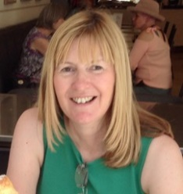
Marie Brett is part of the team at Stockton Borough Council Learning and Skills Service delivering the Library, Information and Archives Services Assistant Apprenticeship. She is a qualified assessor and trainer and is delighted to have the opportunity to contribute to developing the existing library workforce and recruiting diverse new talent.
Marie’s previous roles include leading the public library service in Sunderland, managing information, advice and guidance services across north-east England and working as a careers adviser.

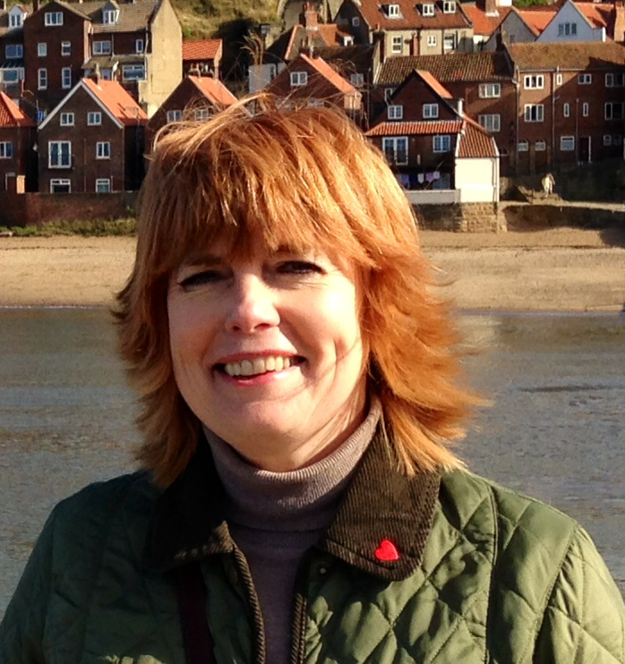
Dawn Beaumont is Head of Library Services, Birmingham City Council, she has worked in public libraries for 25 years mainly within the West Midlands. Dawn joined Birmingham City Council in 2013 when The Library of Birmingham was opened.

Daniel Clark is a Creative Director, writer and curator who specialises in imaginative ideas that connect people with the magic of stories. He works across art-forms, driven by the desire to find new ways of bringing narrative content to life.

He has presented his work, ideas and innovations across the world in partnership with organisations including The Met Museum, New York; The Skywalker Ranch, California; Stanford University and The Melbourne Recital Centre.
The son of two authors, libraries have always been magical spaces for him and he is excited to be part of the team exploring new ways that they can evolve and stay relevant to new generations.

Jonathan Douglas CBE, Hon FRSL is Chief Executive of the National Literacy Trust. Previously he was Head of Policy Development at the Museums, Libraries and Archives Council, where he also worked as Head of Learning and Access. Prior to that, he was Professional Adviser for Youth and School Libraries at the Chartered Institute of Library and Information Professionals. He has also worked as a librarian and in children’s services for Westminster Libraries.

Jonathan is on the Advisory Committee of The Booker Prize, a trustee for World Book Day and The Philosophy Foundation, and a Governor at his local primary school. In 2020 Jonathan was awarded a CBE for services to education and in 2021 he was elected as an Honorary Fellow of the Royal Society of Literature.

Dionne Hood is a development officer at Bradford Libraries. Dionne is currently working on implementing the new model for Bradford libraries with a special focus on the Health and Wellbeing, Reading, and Culture and Creativity Universal Offers. Dionne started working in libraries 15 years ago after being made redundant from lecturing in art and design, she still works as an artist when she can and is about to complete her part time MA in Visual Arts.

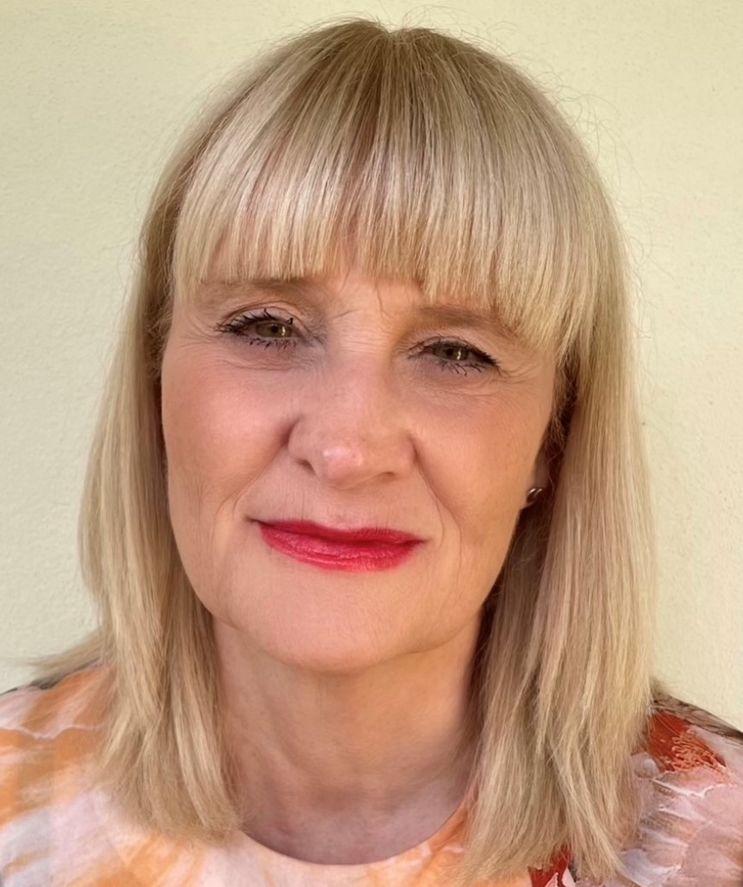
Sharon Kirkpatrick is the Senior Manager Early Help and Dorset Library Service. Responsibilities include service development, commissioning and delivering arts and cultural projects which contribute to local and national priorities by connecting communities and achieving health and wellbeing, digital and cultural outcomes. As a seconded advisor to the DCMS Libraries Taskforce from August 2015-March 2016, Sharon led on the production of two guidance documents, Libraries shaping the future: good practice toolkit and Community libraries: good practice toolkit and contributed to Libraries Deliver: Ambition for Public Libraries in England 2016-2021.

A past chair of ASCEL (Association of Senior Children’s and Education Librarians) she has helped shape library services for children and young people nationally through innovation, engagement and partnership working. Sharon is an Institute of Leadership and Management Executive Coach and Mentor.

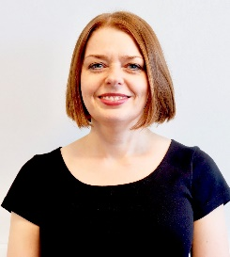
Suzanne Fitzpatrick is Professor of Housing and Social Policy in the Institute for Social Policy, Housing and Equalities Research (I-SPHERE), Heriot-Watt University. Suzanne completed her PhD on youth homelessness at the University of Glasgow in 1998. She subsequently held a number of posts in the Department of Urban Studies at the University of Glasgow, including ESRC Research Fellow in Housing and Social Exclusion and, latterly, Lecturer in Housing and Social Policy.

From 2003 to 2010 Suzanne was Joseph Rowntree Professor of Housing Policy and Director of the Centre for Housing Policy at the University of York. Suzanne took up her Research Professorship in Housing and Social Policy at Heriot-Watt University in July 2010. Suzanne specialises in research on homelessness and housing exclusion, and much of her work has an international comparative dimension. Suzanne is on the editorial board of several journals and is a former Editor-in-Chief of the International Journal of Housing Policy.

David Gimson, British Library Business & IP Centre National Network Manager (@BL_DaveGimson) heads up the British Library Business & IP Centre National Network, working with libraries across the UK to set up and establish support services for aspiring entrepreneurs, small business owners and self-employed individuals.

The services support over 25,000 people per year through access to business information & intellectual property collections alongside a programme of one-to-ones, webinars and events, with unrivalled reach into communities and under-represented groups in business. Following £13m investment from HM Treasury and DCMS in 2020, Dave is leading on the expansion of the Network to over 20 regional Centres and 100 local centres in urban, rural and coastal libraries across the country.

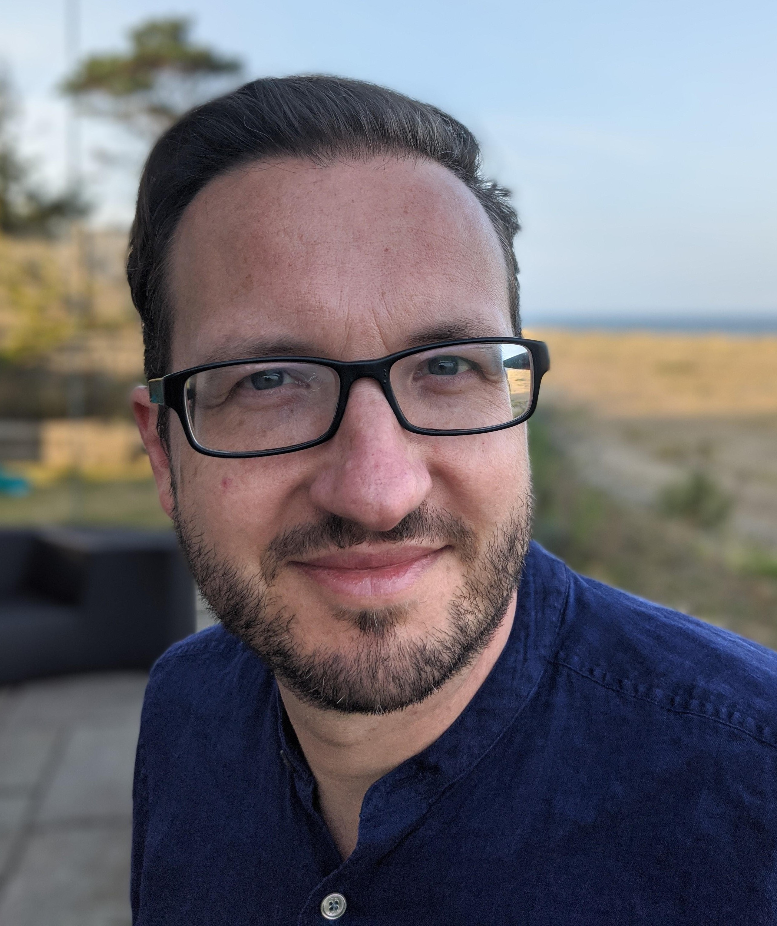
Robin Hewings is Programme Director of the Campaign to End Loneliness. He leads a team driving action on loneliness through research, convening and influencing. Highlights include publishing reports on the Psychology of Loneliness, Promising Approaches Revisited and Loneliness Beyond Covid-19.

Before working at the Campaign to End Loneliness he focussed on health: putting together evidence and communications to make change on issues such as the plain packaging of tobacco and the prioritisation of diabetes in the NHS.

Isobel Hunter is the first CEO of Libraries Connected and led its transformation from a membership body into a professional team. Under her leadership the team has more than doubled in size and secured over £1 million additional income to deliver development programmes including for diverse leadership and income generation. The focus of the past year has been supporting libraries to adapt to the pandemic, for which Isobel was awarded an MBE in the Queen’s Birthday Honours.

Isobel began her career as an archivist and for 15 years she managed extraordinary collections including at the Wellcome Library, Marks & Spencer and the National Gallery. She then moved into sector leadership roles with the Museums, Libraries & Archives Council, Arts Council England and The National Archives. The focus of these roles was capacity development in libraries, archives and museums, achieved by capitalising on the expertise within these sectors. Some key achievements include delivery of Stories of the World – one of the major projects of the 2012 Cultural Olympiad, and the largest ever youth participation project in museums; and development of Archives Unlocked – the government strategy for archives.

Isobel believes in the power of libraries to change lives and to build stronger and happier communities.

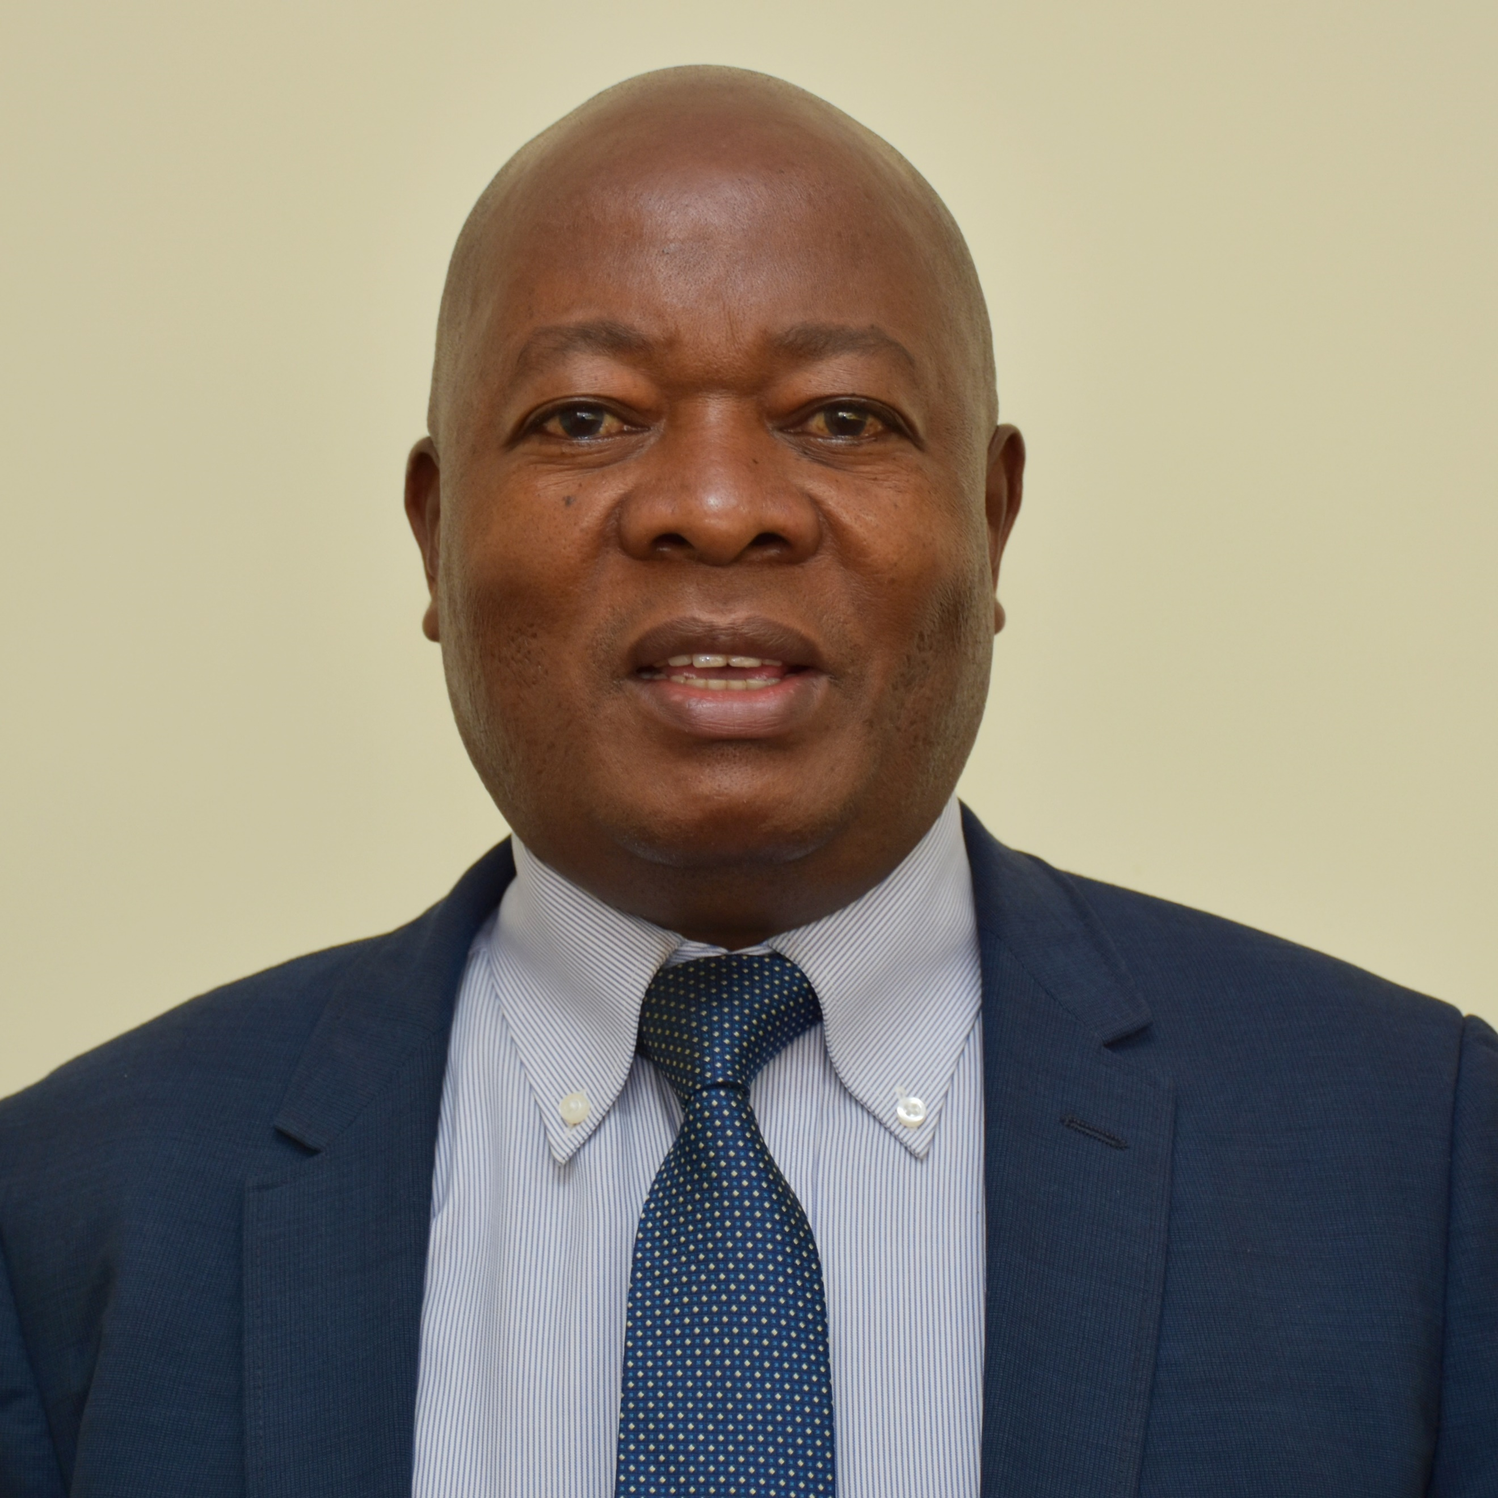
Dr. Charles Nzivo joined Kenya National Library Service Board as a Graduate Assistant in 1994 and rose through the ranks, becoming head of the department of Research and Development as the Principal Research and Development Officer in 2014, a position he holds to date, and being appointed Acting Deputy Director, Technical Services in December 2020.

Dr. Nzivo has over 20 years’ experience in Public and National Library Management, leadership and community development; 8 years as a researcher and 6 years as a lead Consultant in Library & Information Services in Public & Private Sector & Universities.

During his service with the board, Dr. Nzivo has successfully spearheaded key partnerships on establishment of library services in county governments and universities and other institutions. He was the Lead consultant in the establishment of Resource Centres in NACADA & IRA, Academic Library in RAF International University and Taita Taveta Mobile Library project with the Taita-Taveta County Government. His role in research and consultancy has been instrumental in enabling the organization to execute its mandate in provision of guidance to institutions in the field of library science.

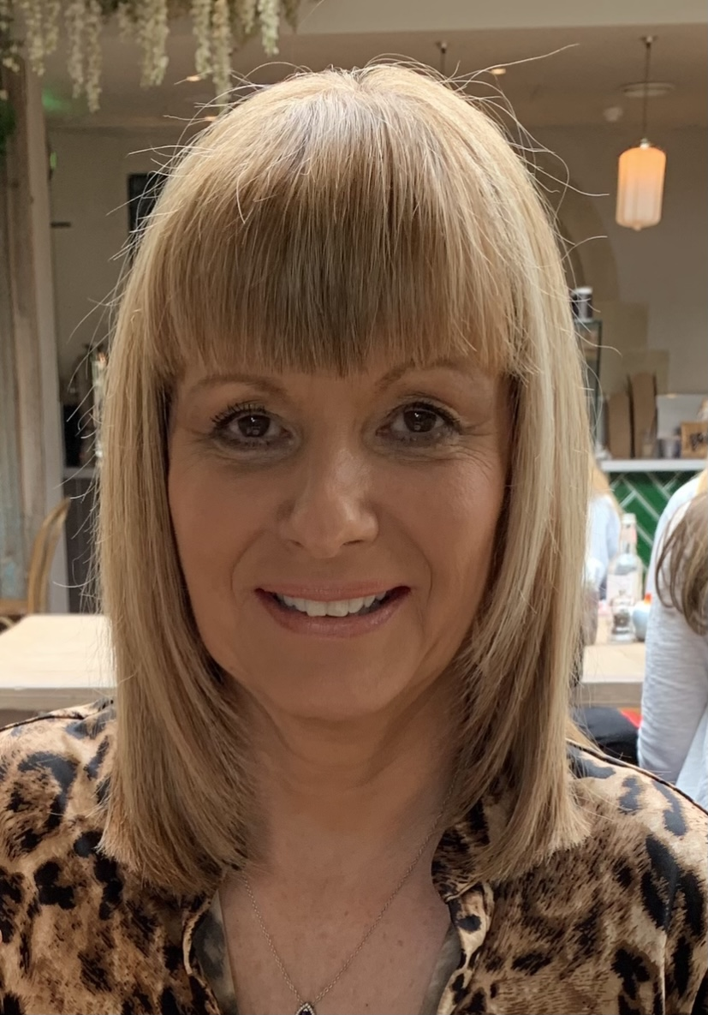
Carol Stump has worked in libraries throughout her career, starting as a library assistant and working her way up to becoming Chief Librarian for Kirklees Council. She became President of Libraries Connected in June 2020 and has been key to supporting libraries through the pandemic and out of lockdown.

She has led her own library service through dramatic change, successfully getting the buy in of Elected Members, Senior Managers, Staff, and the Community, developing new models of delivering the service to meet both the outcomes of the Council and national library outcomes.

She believes the physical library space is vital for effectively meeting the needs of the most disadvantaged and isolated in our communities and she represents Libraries Connected on the government’s Tackling Loneliness Network, positioning libraries at the heart of this vital work.

Krystal Vittles is the Head of Service Delivery at Suffolk Libraries, an independent library mutual which runs the library service in Suffolk. Krystal started her career as a school librarian and specialised in high school literacy and information development before expanding this skill set across all age groups. It is this passion for equitable opportunities to develop vital literacies which has driven her professional career.

After leaving the education sector and working in a local authority to develop her skill set, she moved to Suffolk Libraries in 2014 and worked as the development manager for the new delivery model. In 2018, she became head of service delivery and is now responsible for operations and delivery across 44 libraries, three mobiles and 10 prison libraries. She also oversees the service’s major contracts which includes a mental health and wellbeing service, the National Portfolio Organisation status from Arts Council England and prisons.

Krystal is involved in many projects with partners around Suffolk and the country including as chair of east of England Association of Senior and Children & Education Librarians, chair of the Engaged Communities taskforce in Suffolk, and she is also a trustee of a local literacy charity.

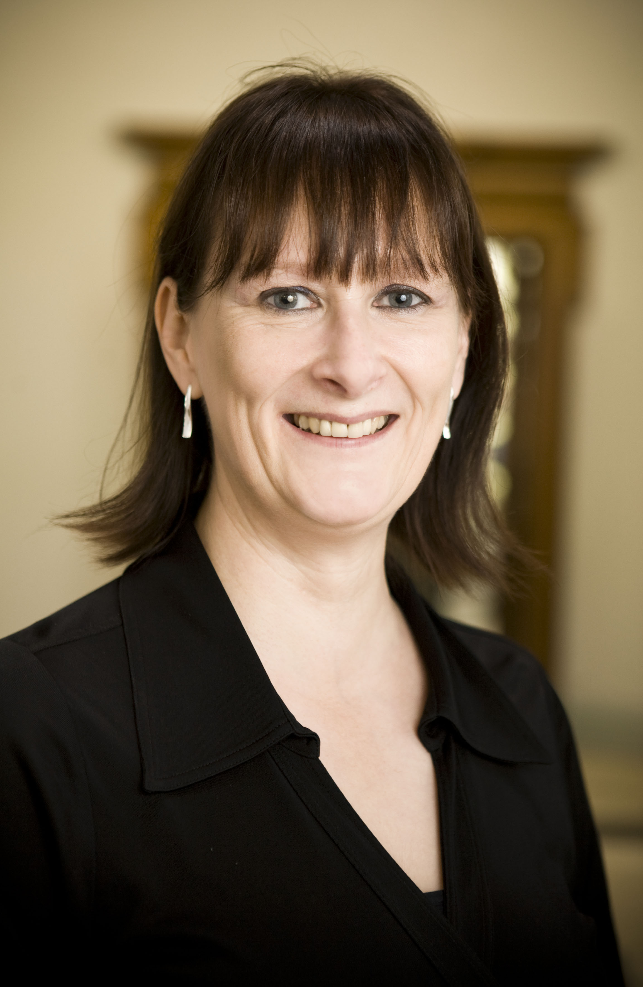
Fiona Williams began working in public libraries in 1988 for Dorset as an Assistant Lending Librarian. Since then, she has had a variety of jobs in libraries culminating in a move to York in 2004, where she developed the Explore vision. Explore Centres are places where a world of possibilities and opportunities open up for everyone.

She has worked nationally as President of the Society of Chief Librarians, advocating the power of libraries at Government level.

As a member of York Cultural Leaders group, she has been developing partnerships with other arts organisations to demonstrate the key role that libraries have in bringing the best culture into people’s lives. She believes passionately in the power of libraries to change people’s lives for the better.

Sponsors

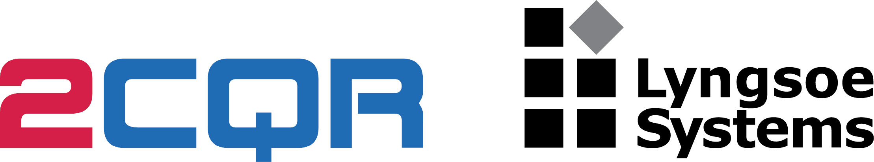
2CQR Lyngsoe offer library systems and automation with RFID technology. We help libraries work smarter and save time on material handling with smart library solutions. Our solutions are standards-compliant as well as practical, affordable and innovative. We have our own nationwide network of engineers and consultants dedicated to libraries across the UK and Eire. Trusted by libraries for over two decades. Come and discover our Intelligent Material Management Systems - IMMS™ that gives public libraries and academic libraries control of collection, space, and float management.

Axiell ALM Ltd provides software and services for public libraries, specialist libraries, school libraries, school library services, archives and museums, which help organisations to organise and share culture and knowledge with the world. Our solutions help our community of customers to manage their collections, encourage reading, preserve cultural heritage, improve learning and increase engagement with the public.

We’re made up of groups of local, accessible teams. We have a variety of small cooperative offices in locations that are close to communities of our customers, and our approach is a personal one. In the UK we have two offices, one in Nottingham and one in Manchester.
Our business is all about ensuring the long-term sustainability of the sectors we serve. Our solutions help our customers to excel in an increasingly digital environment. We stay close to our customers ensure we understand their changing needs and can adapt as a partner for now and the future.

Come and speak to us about your library management requirements and to see our modern cloud based LMS.

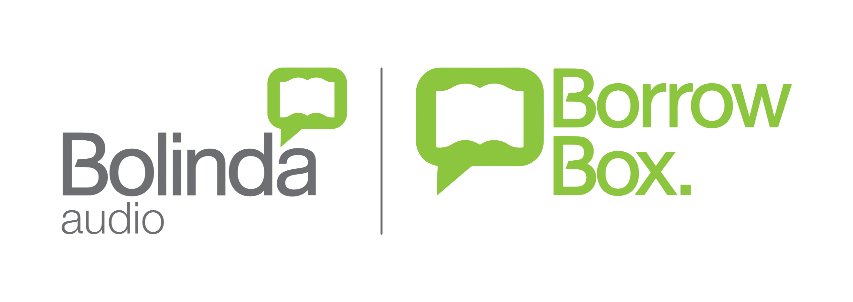
Bolinda is the world’s most entrepreneurial and innovative audio publisher. We created and made the audiobook category fun and we have the most visible audiobook brand in the world.

We are also the creators of BorrowBox.

BorrowBox is the number one solution for eBooks and eAudiobooks, providing the best range of UK and International publishers directly to library users. Through the market-leading ordering portal, BorrowBox Connect, library buyers can browse carefully curated content collections from the world’s top publishers and view the most important new releases as well as bestselling backlist. It is the exclusive digital eBook and eAudiobook solution in Ireland, Wales and for major UK consortia such as AGMA and Libraries West.

Our vision has always been to create a digital experience for libraries and library members that rivals consumer brands. To create a user experience that is world class – designed to be simple and made to inspire.

With BorrowBox, your library in one app, our vision is now a reality.

CollectionHQ is the world’s leading collection performance improvement solution for public
libraries, based on the proven Evidence Based Stock Management (EBSM®) methodology. By
analysing detailed trends of how the library’s collection has been used over time and comparing
this with current provision, collectionHQ provides action plans to help librarians develop and
manage their collection, saving time and money, improving turnover and aligning the collection
with local demand. For more information please visit www.collectionhq.com

D-Tech International Ltd, launched in 2002, is one of the UK’s leading suppliers of high performance technology products and services for public space locations in the UK and overseas. Our success has been built in the library sector but in recent years we have seen an increase in cross-sector demand for our EM, RF, RFIQ and RFID technologies for tracking, managing, protecting and forecasting demand.
We design, manufacture and install RFID, EM, RF and RFIQ Security, self service & stock inventory, book vending, library management software including smart device apps, laptop self service lockers and thermal imaging people counters. App. , earning a reputation along the way as creative solution providers and forward thinking developers of new products to meet the needs of rapidly changing consumer demands.
Excellent customer service with an emphasis on direct contact and support has been crucial to our success.

Innovative, a ProQuest company, provides leading technology solutions and services that empower libraries and enrich their users worldwide. Innovative offers one of the most comprehensive portfolios of library automation products on the market today, serving academic, public, national, corporate and special libraries and consortia. Headquartered in Emeryville, California, Innovative has a global presence—serving thousands of libraries in 66 countries and offices worldwide.

Insight Media is a leading library technology partner in the UK for the provision of PC booking, print management, Wi-Fi printing, Wi-Fi authentication, and kiosk software services.

Lorensbergs works closely with libraries to improve access to services and resources. Our market-leading solution, Netloan PC booking provides a comprehensive session management system for greater control and accessibility to library PCs, together with self-service print payment and release. Netloan Wi-Fi print gives library users the opportunity to print from their smartphones, tablets and laptops in the library and from home.

The Netloan portfolio gives you the technology and data to meet greater demands on library resources. With our integrated solutions, library policies and administration can be managed holistically. Administrative tasks are easily achieved with centralised web-based access, allowing library staff greater freedom to ensure their libraries operate smoothly and efficiently.

Netloan integration on self-service payment kiosks achieves a number of further benefits. It provides library users with the ability to make PC bookings and self-service print or PC payments at the same point as carrying out book-related transactions on Bibliotheca kiosks. This relieves pressure on staff and can even support longer opening hours. It also helps save on valuable floorspace in the library.

Talk to Lorensbergs today about your libraries’ requirements for better managed PC and printing services.

Call 01992 415505
Email enquiries@lorensbergs.co.uk
www.lorensbergs.co.uk

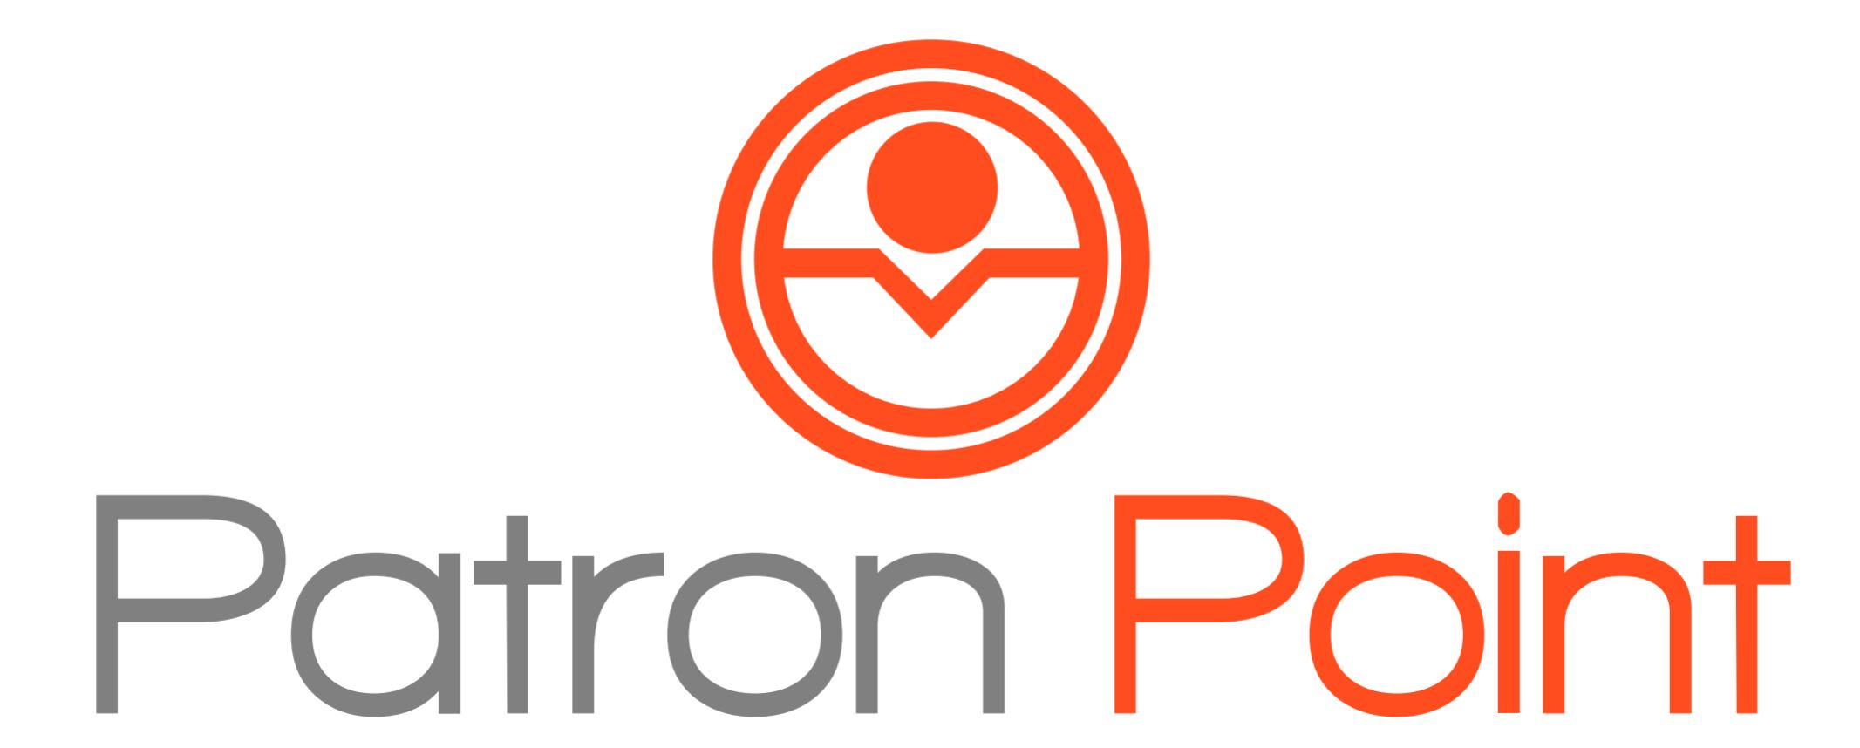
Patron Point is the leading marketing automation platform driving patron engagement in hundreds of public libraries around the world.

It is the first of its kind patron engagement platform built specifically for public libraries harnessing data from a wide range of library systems including the LMS, ebook platforms, event/PC/room booking systems, databases and website to build a unified view of the patron’s engagement with the library.

With Patron Point, libraries more fully engage their patron audience across multiple channels including email, website forms and pop ups, web widgets and social media tracking. Libraries can benefit immediately from a foundation of Proven Programs™ or create their own workflows that are customized to their unique user communities and needs.

Libraries interested in learning more about Patron Point can visit the company’s website at www.patronpoint.com and request a short online demo.

SirsiDynix believes in the power of libraries. Transforming and shaping their communities every day, that power inspires us to connect people with knowledge at more than 23,000 Libraries worldwide. SirsiDynix technology combines relevant resources with the Best Library User Experience (BLUE). With our Best-of-Breed approach, SirsiDynix gives libraries the greatest and most expansive range of options for their software. Complemented by the most experienced training, consulting, and support staff in the industry, SirsiDynix helps libraries to reach their highest potential while serving their communities. To find out more, visit www.sirsidynix.com.

SOLUS is a Glasgow, UK based technology development company focusing on bringing new and leading edge products to libraries around the globe. These products are designed for operational efficiency, patron engagement and increasing library relevancy.

thedesignconcept Ltd designing sustainable libraries for the future, planning and assisting you with economic recovery and encompassing your digital inclusion. As the global design hub for Lammhults Design Group, we draw inspiration from libraries around the world to design award-winning, forward-thinking libraries to suit all budgets.

Libraries Connected awards

Libraries Connected launch its new awards to recognise all the amazing achievements of library staff over the past year. The awards are linked to the Universal Library Offers and Promises and will be made in the following six categories:
- Culture and Creativity
- Health and Wellbeing
- Information and Digital
- Reading
- Children Promise
- Visual and Print Impaired People’s Promise.

Libraries Connected is delighted that this year’s awards are generously sponsored by OverDrive, the leading digital reading platform for libraries and schools worldwide, and creator of the award-winning library reading app, Libby. OverDrive is a regular sponsor of the Libraries Connected annual seminar and have worked closely with Libraries Connected to support libraries during the pandemic.

The awards will be presented to the winners at the seminar dinner which begins at 7pm on Tuesday 19 October.

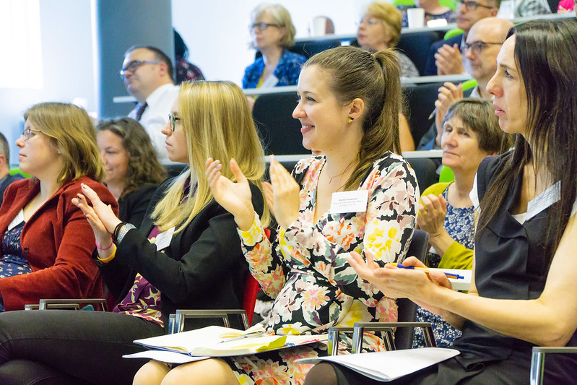

Award sponsors
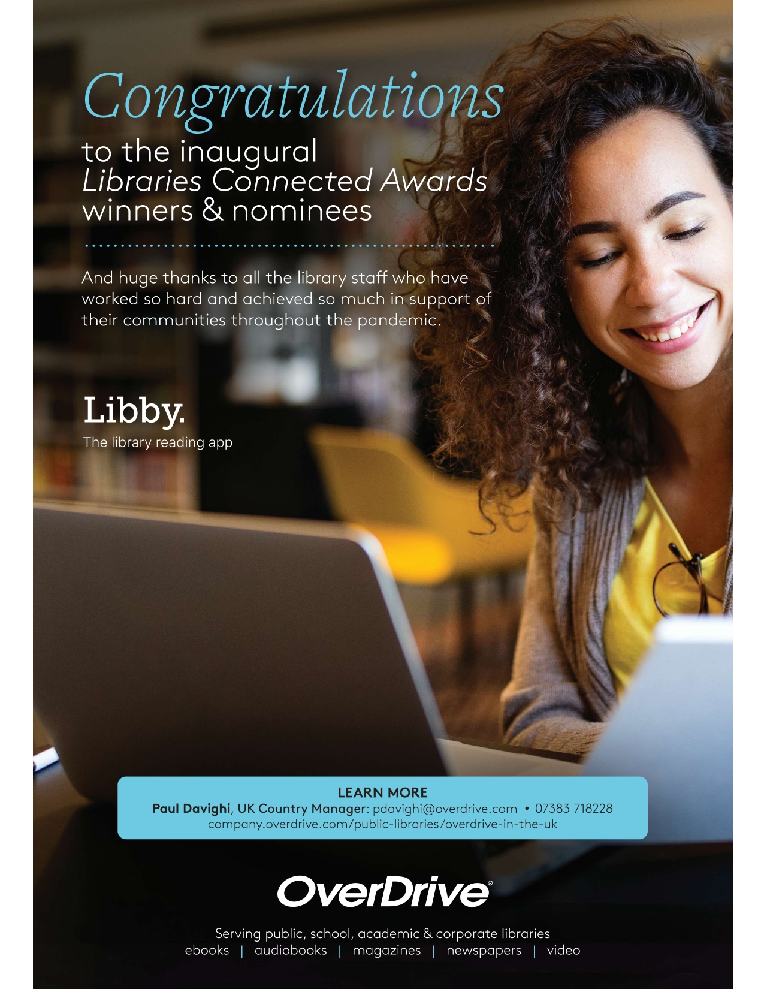

Venue

The seminar is taking place in the Woodlands Event Centre at Wyboston Lakes, a stunning new venue for us in Bedfordshire, located midway between Milton Keynes and Cambridge with easy access to both. M1, M11 and A1.

The Woodlands Event Centre is purpose built with a number of fantastic event spaces suited to a variety of events. The centre includes:

- The Rosewood Conference Suite where most of the event will take place is a superb flexible space which can host up to 620 delegates theatre style. With moveable walls, self-contained bar, leading AV and tech, the space can be used for multiple purposes.

- Training and meeting rooms are all air conditioned, beautifully furnished and equipped with great easy to use tech. Creative spaces are located throughout the venue for out-of-meeting interactions, with casual lounges, campfire chat areas and social fuelling stations.

- The Olive Restaurant where we’ll be having lunch has a Mediterranean style with a clay oven and staple dishes from Greece, Italy and Spain. Menus can also include North African and Middle Eastern cuisines, for a different twist. Set menus have a variety of choice and all food is cooked using locally sourced produce.

- The Cedar Lounge, where refreshments can be taken throughout the day, provides delegates with a comfortable space to catch up with colleagues during breaks and after events and is where the Sponsors showcase will take place.

Other on-site facilities include a business centre, fitness suite, swimming pool and walking/running routes.

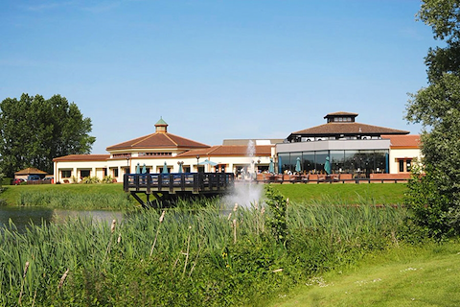

About Libraries Connected

Libraries are at the heart of communities, reflecting and responding to local needs.
They get more visits each year than any other cultural service, with a reach that extends right across income brackets, ages and ethnicities. They play an important role in promoting well-being and community cohesion by producing a range of cultural activities with their local communities and providing many with access to vital online services.
Maintaining and building on the power of libraries is the heart of our mission. Our Universal Offers are key to this and cover the key areas of service which our stakeholders see as essential to a 21st century library service: Culture, Digital, Information, Health, Learning and Reading. Underpinning these offers are our Six Steps Promise for the visually impaired and our Children’s Promise which aim to ensure that these offers remain accessible for all.
We are funded by Arts Council England as the sector support organisation for libraries to:
- Represent the public library sector and communicate the value of libraries
- Connect partners to local libraries by brokering national relationships with a wide range of organisations and individuals
- Improve library services by developing and sharing best practice, providing training for library staff and facilitating a network of library leaders in the UK
- Drive innovation and new thinking on the role of libraries in a modern society.
Libraries Connected is a membership organisation, representing library services in England, Wales and Northern Ireland. For more information visit www.librariesconnected.org.uk

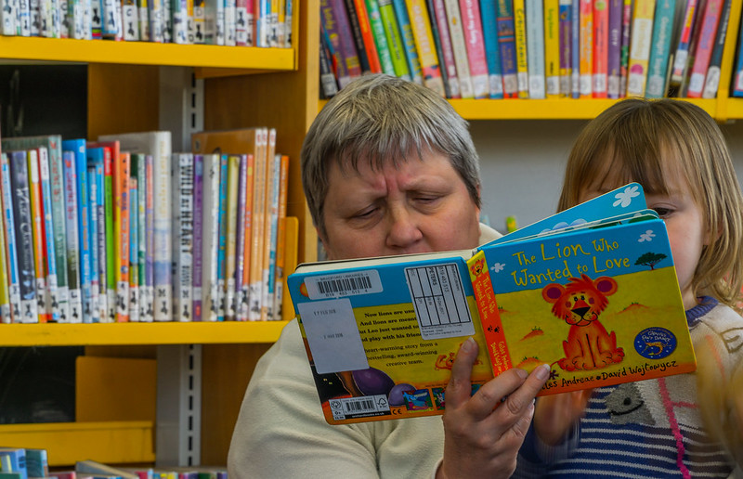
Email:
info@librariesconnected.org.uk
Twitter:
@libsconnected
Or join our mailing list at:
librariesconnected.org.uk/signup

Don’t forget to recycle your brochure when you’re finished with it, and please reuse your conference bag!

A 2006 study conducted by the Environment Agency into the lifecycle of carrier bags found that the key to reducing the impact of all carrier bags is to reuse them as much as possible. This year we went with a non-woven polypropylene which you will needed to be reused just 11 times to ensure that it has lower global warming potential than conventional HDPE carrier bags that are not reused, where as a cotton bag would need to be reused 131 times!

