Transforming Leadership: Leading Libraries
Expression of Interest for public libraries

- INTRODUCTION

Public libraries engage with a more diverse section of the population than any other arts or cultural institution. However, our workforce is significantly unrepresentative. In 2015, research highlighted some deeply concerning statistics about the make-up of the workforce. For example, 45% of the current workforce will reach retirement age by 2030, 97% of the workforce self-identify as white compared to 88% of the population and there is still a gender pay gap – in a workforce where 79% are female, 27% of the top earners are men. Moreover, as society and public service rapidly transform, some of the traditional leadership skills may no longer provide the solutions libraries need to survive and thrive in a new world order.

The public library sector does have a rich pool of talented staff who have a deep commitment to libraries and the communities they serve. Our Arts Council England funded Transforming Leadership Programme aims to harness that talent through an inspirational 30 month learning and mentoring programme which acknowledges that leaders may emerge from all layers of a service and which values new talents and skills. We want to develop innovative, entrepreneurial library workers who will have the confidence and the vision to lead teams in tough times and who actively represent the communities they serve. This project will focus on developing leadership among people who are BAME, women and people with disabilities.

- The Transforming Leadership programme will involve 15 library services across England in a project that will adopt a whole-service approach to developing leadership skills.
- The primary focus will be 15 emerging leaders who have the potential to be the library service strategic leaders of tomorrow. They may be nominated by Heads of Service or may nominate themselves but will need Head of Service consent and approval. We are seeking to develop the talents of emerging leaders particularly from under-represented areas of the community. We recognise that leadership is demonstrated throughout a service and so we encourage nominees from any role in the service; they don’t have to currently occupy a management role.
- The programme will also provide leadership development for the Head of Service in each library service selected.
- The emerging leaders will also mentor two additional members of staff identified as ‘hidden talent’ within their service.
- The emerging leaders will shape their own action learning projects. New leadership skills will therefore run through all layers of the workforce and create a ripple effect throughout the library service. In total the project will involve 60 library workers and through the accompanying online learning package, have the potential to engage far more.
- Although participants will need to be involved in up to four days of classroom-based learning, local place-based and online learning are significant features of this programme – and most of the activity will take place in participants’ workplaces.

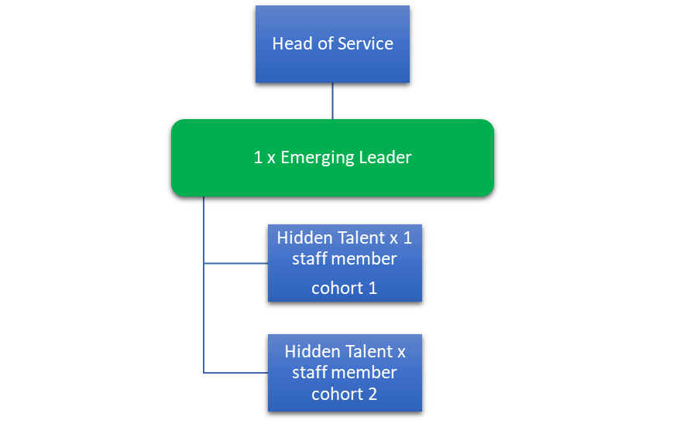
Fig 1: Leading Libraries model

- AIMS

The Transforming Leadership programme has the potential to make significant changes for:

- Individuals it will boost confidence, skills, knowledge and motivation. It will provide current and future leaders with an understanding of their strengths and areas for improvement. It will offer a clear path for future learning. It will broaden their horizons and networks and enable them to contribute more effectively to their own organisations and will give them an advantage when leadership opportunities arise.

- The library service it will create a more diverse leadership pool within the service which will better reflect the community served, giving the service an advantage in terms of community engagement and trust-building and in developing a new service vision. Leaders will demonstrate new creativity and the potential to find creative solutions. Participating individuals will have new networks to draw upon and the confidence to engage effectively with new partners bringing new collaborative ideas to the service.

- The wider organisation it will create a renewed interest in leadership amongst the whole workforce, and knowledge that they will share and develop with the two people they mentor and beyond. A place-based approach roots the learning within the service, motivating people to use their skills within the service and sector. Through the action learning projects, there is the potential for emerging leaders to introduce changes and new developments to benefit their service and the rest of the workforce.

- The sector the programme will contribute to sector succession planning and innovative solutions to current and future challenges. It will develop people with leadership skills and shared experience who will work together through the programme and support the sector to respond to leadership challenges in new ways. We will share the good practice through our existing networks and our annual seminar with participants becoming positive role models within the sector thus passing on
the benefit to other services.

The programme will leave a legacy of online training and evaluation of a new leadership
model that could be rolled out in future years.

- GOVERNANCE AND EVALUATION

This is a partnership project led by Libraries Connected. We have established a Programme Board which will be chaired by the current Libraries Connected President Elect (who also chairs the Public Libraries Skills Strategy Board). Our partners are:
- CILIP (The Chartered Institute of Library and Information Professionals) (including a representative of the newly formed CILIP BAME group)
- CLOA, Chief Culture and Leisure Officers Association
- LGA, The Local Government Association
- DILON, Diversity in Libraries of the North.

In addition to contracting a leadership development organisation to help us deliver the programme, we will also separately commission independent evaluators to assess the impact of the programme on participants and on library services.

- THE CONTENT

The proposed 30-month programme will include the following components.

Classroom sessions
Three days training/mentoring development for 15 Heads of Service.
Four days training for 15 Emerging Leaders.
Three days training for 30 ‘Hidden Talents’ from the 15 library services (in two cohorts of 15).

Action learning and mentoring
Action learning is at the heart of the programme. Each participating library service will be asked to contribute £2000 over the course of the programme (over three financial years) to enable the participants to initiate, deliver and evaluate leadership-focused action learning projects in their own service, which have local, regional or national significance.

The project will include a commitment by the Head of Service to supporting the Emerging Leader, through regular one-to-one discussions, and we will also assign mentors who will be able to support each Head of Service through phone calls.

Emerging Leaders will be supported to mentor two cohorts of ‘hidden talent’ within their own service during the 30 months. They will involve the ‘hidden talents’ in the action learning projects and support their participation in classroom learning. Thus, the Emerging Leaders will immediately be able to put their theoretical learning into practice. Heads of Service will be required to support all three members of staff and enable them to work together during the programme.

Pre and Post Conferences
The conference to launch the programme will take place on 4 November in London is open to all interested heads of public libraries in England. There will be an evaluation event at the end of the 30-month programme and the learning will be shared across the public library sector.

- TIMELINE

Activity | Timeline
Expression of Interest from library services | Oct-Dec 2019
Launch conference | 4 Nov 2019
Closing date for Expressions of Interest from library services | 12 Dec 2019
Selection of successful library services | Dec 2019-Jan 2020
Workshops with Heads of Service | Mar-May 2020
Emerging Leaders programme starts | June 2020
Hidden Talent workshops – cohort 1 | Sep 2020-Jan 2021
Hidden Talent workshops – cohort 2 | May 2021-Sep 2021
Review and evaluation | Oct 2021-Dec 2021
Report and final recommendations | Feb 2022
Programme closedown and showcase conference | March 2022

Please submit Expressions of Interest to adrienne.speake@librariesconnected.org.uk by Thursday 12 December 2019.

Transforming Leadership: Leading Libraries
Expression of Interest

Name of Library Service
Click or tap here to enter text.

Head of Service name
Click or tap here to enter text.

Email
Click or tap here to enter text.

Direct dial telephone number?
Click or tap here to enter text.

A: Details about your workforce

How many actual staff do you have in the service (total number, not FTE)
Click or tap here to enter text.

Please indicate the number of actual staff who fall into the following categories:

Ethnicity | Number

English / Welsh / Scottish / Northern Irish / British

Irish

Gypsy or Irish Traveller

Any other White background

White and Black Caribbean

White and Black African

White and Asian

Any other Mixed / Multiple ethnic background

Indian

Pakistani

Bangladeshi

Chinese

Any other Asian background

African

Caribbean

Any other Black / African / Caribbean background

Arab

Any other ethnic group (please indicate)

Age profile | Number

0-19

20-34

35-49

50-64

65+

Not known

Gender identity | Number

Male

Female

Non - Binary

Please indicate the number of staff who identify as a deaf or disabled person or have a long-term health condition Click or tap here to enter text.
B: The change this programme will make to your service

What are you hoping to achieve through the programme? What difference will it make to your service and the community it serves? (No more than 200 words)
Click or tap here to enter text.

How are you expecting that the programme will change culture or processes within your service?
Click or tap here to enter text.

What are the key leadership challenges and constraints within your service (other than lack of resources)?
Click or tap here to enter text.

What difference will the programme make to you as a leader?
Click or tap here to enter text.

C: Details of your nominated emerging leader and hidden talents

Name of the Emerging Leader you are nominating:
Click or tap here to enter text.

What is their current role in your service?
Click or tap here to enter text.

Why are you nominating this person? (Please highlight some of their achievements so far and your reflections on their potential - no more than 400 words)
Click or tap here to enter text.

Please indicate their ethnicity using the list above
Click or tap here to enter text.

Please indicate their gender identity using the list above
Click or tap here to enter text.

Do they have a disability?
Click or tap here to enter text.

D: Service commitment

Can you confirm that your service will commit £2000 (cash not in-kind?) over the course of the project for an action learning project in your own service?
☐

Can you commit to contributing to the evaluation of the programme?
☐

Can you commit to releasing the selected staff to take part in the programme?
☐

How will you and the emerging leader work together to identify and select your ‘hidden talent’?
Click or tap here to enter text.

How will you continue to develop leadership within your workforce after the programme ends?
Click or tap here to enter text.

E: Emerging Leader statement

Please include a paragraph written by the nominated Emerging Leader explaining why they wish to take part in the programme (no more than 400 words)

Click or tap here to enter text.

