Identifying the Social Economic Value of Revoe Library

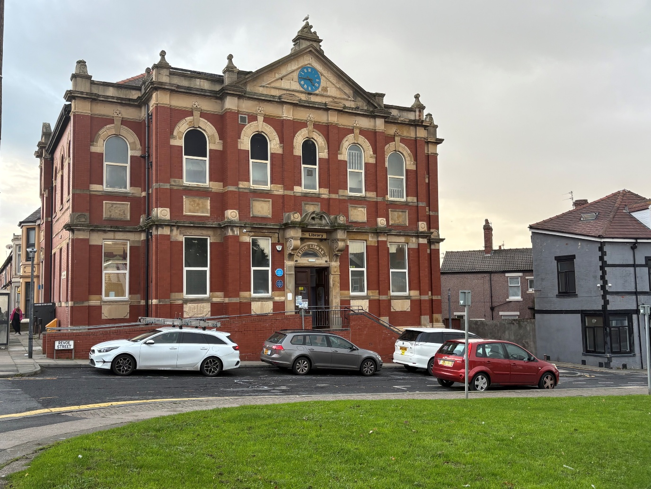

Contents
Acknowledgements 3
Executive Summary 4
Data Methodology 9
Surveys and Focus Groups 15
Conclusions 21
Recommendations 23

Acknowledgements

This project was funded by the HDRC.

This report has been written by Chad Bentley of Libraries Connected and Richard Fordham of InsightEcon, who wrote the Data Methodology section based on his data analysis. All aspects of the report and connected work have been supported by Alan Woods, Claire Greaves, Lois McWilliam, Molly Grundy and more from Blackpool Libraries. Thanks to Vicky Clarke and all other staff at Blackpool Libraries who have been extremely helpful with the whole process. Thanks to Ruth Henshaw and Karen Gratrix from HDRC for their support.

‘Blackpool Library Service has been in the privileged position of being able to work with Libraries Connected and an emeritus professor from the University of East Anglia on this exciting research project.
The motivation was to gain a better understanding of the monetary value that could be attributed to the vital work our libraries do. We focussed on one library, based in one of the most deprived areas of the country, in order to simplify the project. Working with the residents on the project has been the highlight of the work. Listening to them speak about, sometimes very personal, issues gave us an added respect for the lives some people are living around us.
We aim to roll out the project to all 8 branches and present to Cabinet and Chief Executive in good time.’ Vicky Clarke, Head of Blackpool Libraries

Executive Summary

- A Social Value based data project which identifies extra-monetary social value for Revoe Library.
- The project used a research methodology that combined desk research, qualitative analysis (surveys, focus groups) and quantative data analysis (using the EVOLs ((Economic Value of Libraries)) tool to evaluate the value of the library.
- Despite it’s small size and limited opening hours the library produces a base value of £1.4 million annually.

Revoe Library is a small branch library in Blackpool. Sitting within walking distance of the town’s famous promenade and attractions, it is one of the smaller libraries in the service, ranking 8th for visitors with 15,032 visits between February 2024 and January 2025, and 6th for book issues, with 4,036 issues in the same period.
However, these figures only tell part of the story and do not account for either the evolving identity of libraries and their increasing value to the communities they serve. Revoe provides vital services every day, helping lift its community by offering different kinds of support and giving people opportunities and skills to help improve their lives all of which goes beyond the traditional expectations of a local library.

Given that 78% of the population live within a 30 minute walk of a public library they are often the most accessible and available council service in the area and, in a time of a growing lack of confidence of the public with institutions, have an uncommonly high level of trust from the community shown by the fact that 87% of people are aware of the location of their nearest library. Revoe is a prime example of this, with people using the library to access, or enquire about, wider council services. The library staff offer support ranging from signposting to supporting users to access and use various resources that they otherwise would not be able to.

In an increasingly digital age, libraries provide an invaluable service to those without the skills or resources to keep up. This is a known need in Blackpool, based on past initiatives such as The Digital Blackpool Project in 2023, and the fact that the areas around Revoe Library are marked as high risk to digital exclusion on the DERI scale created by the Greater Manchester Combined Authority. Libraries are one of the few public spaces offering access to Wi-Fi and use of computer equipment for free or extremely small costs for services such as printing.

Digital inclusion also has big implications to do with the health of communities, with those who rely on the library for digital access needing to use their services for various purposes such as booking GP appointments and researching health issues. In the more traditional sense as well, books can be used for understanding support of those living with certain conditions and libraries offer a clear social aspect that can be vitally important to both physical and mental health, such as reduction in social isolation and group therapies.

This report aims to analyse the value of Revoe library from a health economic perspective, highlighting its value to its users, the wider community as a whole and within the wider frameworks of Blackpool council. It will show the value and benefits of the good work already being conducted by the library and the opportunities to expand that further.

This project follows on, and uses the methodology from, the Libraries for Living and Living Better report from 2023, created by a team of academics, including health economists, literacy experts and computer scientists, from The University of East Anglia in collaboration with the Libraries Connected East of England Region (containing library services such as Essex and Hertfordshire). That project used a combination of quantitative and qualitative research, building case studies of library offers and events across the region and assigning health values to those based on their own data and other established academic research.

This report was hugely positive, and extremely well received in the library sector and beyond. It’s main finding was that libraries offer £3.4 billion of value every year, with branch libraries generating £1 million.

Part of this project’s methodology was the creation and use of the EVOLs (Economic Value of Libraries) tool. Though still a prototype designed as part of that project, the tool itself has created a lot of excitement within the sector, especially as so much focus is now being placed on data and has spawned a lot of individual projects covering different library services or entire regional networks. This project at Revoe allows the tool to be tested looking specifically at one small, individual library and the community it serves.

The use of this tool in relation to Revoe came about following a visit by Libraries Connected to Blackpool Libraries where we had the opportunity to chat to staff members of all levels within the service. One of the focuses was of the closure of Revoe Library for several weeks due to its use in the 2024 Blackpool South By-election. This came at a critical time for the staff at the library as they had been putting a huge amount of effort into their outreach, particularly aimed at the Eastern European and Southern Asian communities in the area, which have grown significantly in the last few years. The closure caused a lot of that good work to be undone and from which it is still recovering, despite the best efforts by staff.

Despite this setback, the library is still providing an excellent service and support that consistently goes above and beyond traditional expectations for a community that needs it. As one librarian told me ‘People have a lot of pride in coming from Revoe’ and that ‘there’s a strong sense of community that, for many people, the library sits at the centre of.’ This report aims to provide evidence and show how the library can become an even more vital part in helping the community thrive.

As mentioned, this project uses a variation of the established methodology from the Libraries for Living Report, benefitting not only from the creation of the EVOLs tool but the experience of the team who completed that report. Indeed, project member Richard Fordham, of InsightEcon, was part of that original team and one of the designers of EVOLs, so able to bring his expertise to the data side of the research.

The quantitative and qualitative strands were in constant dialogue, with the data work able to offer insights to be expanded on, and the findings in the surveys and focus groups were able to offer evidence for the data analysis and connect the data to the lived experience of the users of Revoe Library.

A key example of this is in the question of loneliness which, with social isolation, is a massive health determinant and could have a big impact on the figures found through the data analysis. However, loneliness is a difficult thing to measure, both in terms of how many people it effects and how severe it is. The responses from the qualitative research, therefore, were vital in showing how loneliness and social isolation affects the community of Revoe and how it connects to their use of the library. Although we had limited local data on social isolation, we believe it to be much higher than nationally, but we have kept our estimates cautious in the economic modelling. Even so, it can make a substantive difference to the value of Revoe’s services.

The qualitative research was conducted by Blackpool Libraries, with support from Libraries Connected, in two rounds consisting of a survey and focus group in each. The anonymous surveys were available for all library users for a period of two months each and the focus groups were open to all, but some users will have faced barriers due to the groups being held on a Monday afternoon on each occasion. The first survey was purposefully broad, focusing on users general feeling and use of the library. The focus group was conducted in a similar vein, albeit slightly more precise as the questions were written in response to the survey answers. The second survey was much more focused on health, both mental and physical, and how users engage with that within the library. Again, these responses informed the questions presented to the focus group. The methodology for the economic valuation and data elements is explained in the next section.

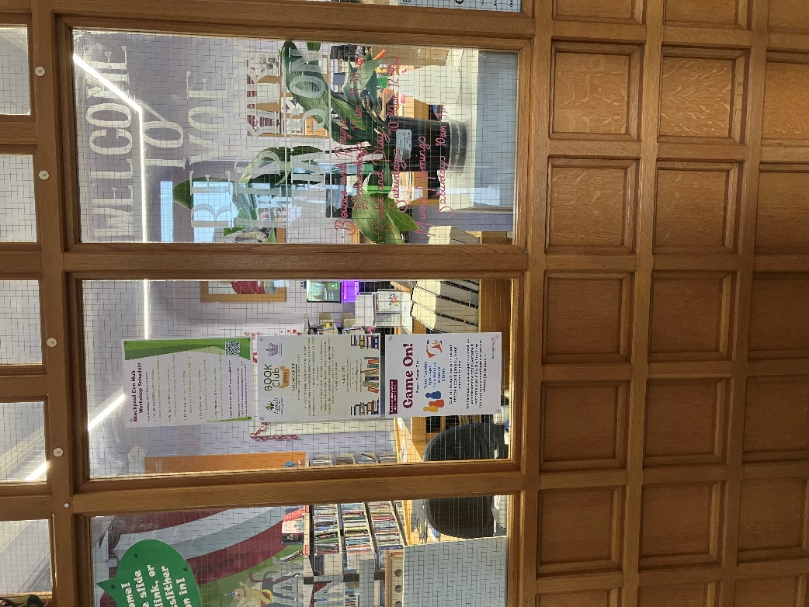

Data Methodology

The data analysis was conducted using the EVOLs (Economic Value of Libraries) tool, which was created for the Libraries for Living report by academics of different disciplines from the University of East Anglia. Through robust case studies and economic analysis they were able to identify a key set of Return on Investment based values for common library activities. Where it was not possible to generate a specific value, equitable public sector based research was used. The tool creates a library specific value by multiplying the value against the number of units, such as event attendees or book issues. These figures are then adjusted to account for running costs to produce the ‘profit’ value. In the model this value can then be adjusted by using relevant multipliers such as the deprivation index or loneliness figures.

The estimated economic value of Revoe Library activities, Blackpool (2024/25)

Results of economic modelling

Methodology

The results were derived from the EVOLS tool and are summarised and attached on the accompanying spreadsheet.

The activity data was provided directly from Blackpool Library Services staff. The monetary values for the ‘per unit of activity’ were taken from the EVOLS tool and represent the closest, or most similar type of activity or proxy, we could find in Blackpool. These values have been rigorously tested during the development of EVOLS and externally validated elsewhere.

The annual footfall for February ’24 to January ’25 was used as the basic value multiplier. This was subsequently adjusted for social deprivation by a weighting of 1.3 taken from published statistics for the area served of 30%, or a factor of 30% above the UK average (g-health index NHS England 2025/26). Although this index is primarily health focussed, we believe health is a good indicator of general social well-being. Therefore, it was used as a ‘proxy’ needs-index for library’s user population generally.

Loneliness was assumed to be at the UK national average level of 7% (Government’s Community Life survey, 2024). Although again, it is believed to be much higher in Revoe’s catchment area (at around 22%) from local health and social care research done recently. However, this depends to some extent on how loneliness is defined from mild to severe.

The scope of activities

The scope of the valuation was taken from three perspectives:

- The various range of services and activities offered currently through the library
- The potential health benefits generated from related activities that may have an impact of the health or its users;
- The potential benefits from reducing loneliness from participation in library services.

These are based on the EVOLS method but also recognise that the wider health and social are more complex to assess. This is because the benefits are often indirect and may not occur systematically in the same way, or with the same intensity for every user who accesses them. The results are therefore shown in four different ways or combinations of value, including the exclusion altogether of health and loneliness, if required. The total sums as well as benefits per user are presented, so that both the total monetary impact and the value per person can be assessed from different perspectives.

Unweighted for social deprivation

Weighted for social deprivation

The total value of all services is nearly £7.7m or a Return-on-Investment (based on all allocated running costs of £137,137 est.) of £55.90. This increases to £9.5m or a RoI of £69.53, if weighted for deprivation.

The total value drops if loneliness is excluded to almost £1.7m or a RoI of £12.23. The weighted total value increases to slightly over £1.7m, if deprivation is included or a RoI of £12.75.

Without just the health benefits (but including loneliness) the total value is £7.3m or an RoI of £53.34 unweighted and £9.2m total, or a RoI of £66.97(weighted).

Excluding health and non-loneliness, the value for other library services is £1.3m (unweighted) or £1.4 (weighted) or RoIs of £9.66 and £10.19 respectively.

Value per user

The total value per Revoe user, excluding heath and loneliness, falls between £68-88. However, with heath and loneliness benefits included, this rises to between £392-510 per user.

Summary of activities

The following volumes of activities were included in the calculation of financial benefits:

Footfall/general browsing (weighted for SE deprivation): 19,542
PC sessions (individuals): 2,656
PC Users: 803
New joiners (all): 162
e-issues: 1,693
Children’s book loans (fiction and non-fiction): 1,535
Adults books loans: 2,465
Health benefits (weighted for SE deprivation): 5862
Loneliness benefits (% of users): 1,368

Value per unit of benefit
These values were taken from the original EVOLS research.
Footfall/general browsing (weighted): £16
PC sessions (individuals): £60
PC Users: £379
New joiners (all): £16
e-issues: £9
Children’s book loans (fiction and non-fiction): £279
Adult book loans: £50
Health benefits (weighted users): £60
Loneliness benefits (% of users): £5,692

Costs of running library
The cost of dedicated staff, heating and lighting and % share of support overheads has been estimated at: £137,137 . These estimates were derived from local figures and staff allocations etc.

Conclusion
It can be seen that even without all the extra health benefits and benefits to loneliness the Revoe service generates a benefit of just over £10 per user annually (or a RoI of 10:1). With these extra benefits that value increases to almost £70 per user.
This is a little higher than expected nationally of a RoI of 4:1 but may be explained by the needs of the local population and the targeting of the library’s services to these needs.

Surveys and Focus Groups

The qualitative aspect of the project was affected by public reaction to a large regeneration project going on in the area. This work will involve a lot of the local area to be demolished, including houses and residences, with people being forced to leave the home they grew up in and many still not knowing what will happen to them. As the most public facing arm of the council in the area, but not being involved themselves, the library has faced a lot of queries and complaints in this area, some of which have been quite emotional, with the library staff handling this as well and as compassionately as possible. Part of this work has involved a consultation process, some of which has made use of the library building out of hours, the heated nature of which has caused reluctance and hesitance of the community with regards to filling out surveys or participating in focus groups. It is likely that this had an impact on the number of participants and responses the staff were able to collect. Despite this, the work was still incredibly insightful in terms of examining how the library is viewed by the community and what people would like more of.

Of the first, more general, survey, there were 13 responses which all highlighted how important the library is to the community and a central part of its users’ lives. The first question asked users to rate their experience in the library and of the 13 responders 11 ranked it as 5 (exceptional), with only one person ranking it in the middle with 3 and one person not answering. This positive experience was reflected further in a later question about frequency of visits, with 9 people visiting the library multiple times a week.

The services people use are also indicative of the role the library plays in their lives. PC access and free Wi-Fi are used by 9 of the responders, followed by book lending, a quiet study space and adult activities being used by 8 responders. This shows that while the more traditional book-based view of a public library is still relevant, it is also incredibly important as a space of digital inclusion. Indeed, the library informed me that giving support and assistance to people using some of digital technology is one of their main activities and they will often spend on average around 20 minutes helping someone in this area. The availability of this one-to-one digital support shows the way libraries are vital in combatting digital exclusion, as that base level of support is available whilst the library is open, rather than at a specific time that some people might not be able to make, or people being lent equipment and then left on their own to use it.

This appetite was reflected further in the first focus group. Of the 6 participants, their PC use included engaging with interests, checking news and sport, job searches and other activities around finding employment and improving research skills and being able to find the right information. The latter option started a good conversation around misinformation and the library’s role around that, stating that now so much is online and there is so much more online people need support not only in finding what they need but evaluating what they have found to avoid things like misinformation and scams. Indeed a few people agreed that IT skills is something in particular the library has helped them with, especially staff teaching them how to do things not just doing it for them, and is something that could be expanded to provide even more support.

The other salient point from this survey, and all of the qualitative research, was the importance of the library as a social space and how much that helps with social isolation, loneliness and people’s mental health.

The biggest impact on this is potentially the most obvious and therefore potentially the most overlooked: the staff. In all the surveys and focus groups the most common refrain was about how helpful, nice and friendly the staff are. In terms of people who are lonely or isolated, or feel any kind of social anxiety the importance of this cannot be understated. Knowing who will likely be working in the library and that they will give a positive experience is incredibly important for the users, and something that may even be a benefit of a branch library over a central one as it is a smaller space with fewer staff needed.

The other recurring feature in this area was fondness for, and desire for more, creative social activities and events as a way to meet people and foster that sense of community that is hugely beneficial to mental health. Half of the participants to the first focus group attend the art club, which is part of the Know Your Neighbourhood fund (the library aspect of which is run by Libraries Connected) which is aimed at reducing loneliness in areas of high need. The art club is a weekly event, where on alternate weeks an instructor is there to teach or support the attendees on a new skill, which they then work on themselves independently the following week.

This skill based, structured approach is one that the users responded to very well as not only does it provide a social element within a small group, but it also gives structure and goals with the different art forms that can be worked towards in their spare time. This sense of structure and purpose gives the club different benefits than similar, more reactive offers such as a mindful drawing session. It also gives the users a huge sense of achievement as not only do they see their completed works on display in the library, but some of their work was also placed in the Grundy Art Gallery in the town centre. Despite the relative geographical proximity of Revoe and the town centre, a lot of these users would struggle to get there or feel too anxious perhaps to go by themselves. With this in mind, the library staff arranged a trip for the group to go and see their work in the gallery, putting on mini buses to go to the gallery and back so the group could see their work on display together.

The second round of qualitative research took a more specialised approach, focusing on how visitors to the library use it in support of their physical and mental health. The second survey had a slightly improved number of responses with 15 and again showed the high esteem the library is held in by the community with 3 people rating it a 4 out of 5 and 12 rating it a 5.

Of the people surveyed 13 of the 15 said they felt coming to the library helps with loneliness and health respectively. In their use of the library for health related reasons 14 people use it to help their mental health, 10 use it to help with wellness and lifestyle, 9 for social and family issues and 8 for using self-help books to better understand a condition or illness. The high use of mental health related services tallies with the 8 out of the 15 responders who say they have problems with their mental health. Other key uses include using the library computers to perform actions such as booking G.P. appointments, renewing prescriptions and researching illnesses.

In terms of physical health, only 5 of the responses said they live with a chronic illness, despite the higher responses elsewhere. There is a chance, however, that this may in part be due to not understanding the terms, as one survey ticked no, but had ‘asthma?’ written in the box. Despite these lower numbers, the fact that the engagement with health related services is so high, it shows that libraries offer access to health services that people would find difficult to access in other ways.

The focus group results back up the survey findings giving specific examples of how the library supports the health of the community with the friendly staff and calming space of the library being repeated throughout the session. Other examples of engagement include someone being diagnosed with an anxiety disorder and using the Reading Well collection of books (collections curated by The Reading Agency around specific health conditions such as anxiety or diabetes) to help them better understand their diagnosis and how they might look after themselves. These two points are key, as they highlight the positives of the calmer, more thoughtful environment compared to issues at other services such as the 8 am appointment rush at GP surgeries or the short appointment times that are not conducive for people to gain an understanding of their diagnosis.

The other salient topic in the session was the importance of social activities in support of mental health. These have so much benefit, including the feeling of community, the structure to someone’s week, meeting new people and even just having a reason to leave the house. Whether through a mental health condition or loss of a loved one, a few people said they really struggled to socialise but that these events at the library helped them make that step and they are now doing so much better. It is also interesting that engagement, and demand, is based on creative, skill-based activities that are not necessarily mental health related. This could be because, to a lot of people, attending an event specifically marketed as mental health related could be off putting but an activity where that is not the focus and there are no perceived expectations or pressures might be more accessible for them.

Other striking outcomes from the focus groups, include the social aspects of the library, especially as relating to the use of it as a warm space in winter and a cool one in summer. Various members of the group mentioned using the library in these ways both to help with bills and to keep warm or cool. This obviously has a big health implication, supporting users to avoid health issues related to extreme temperatures, but also providing financial aid in lieu of saving on bills for people on limited fixed income. One attendant also informed the group that not only was it through the library that she was informed about a heating grant she was eligible for, but the librarian sat with her on the computer and helped her access and apply for this resource through the online portal.

These actions, alongside even the more intense interactions relating to the aforementioned regeneration project and the use of the library building in the public consultation, show that to many the library is the main way they can access local services. Whether this is for signposting, extra information, the use of digital resources to access provisions or even support completing processes. When asked as a follow on question in the focus group about whether the library was their main way of interacting with the council on related matters most members replied positively, with one person saying that they didn’t need to worry about how the library staff would respond, they knew that they would be kind and helpful.

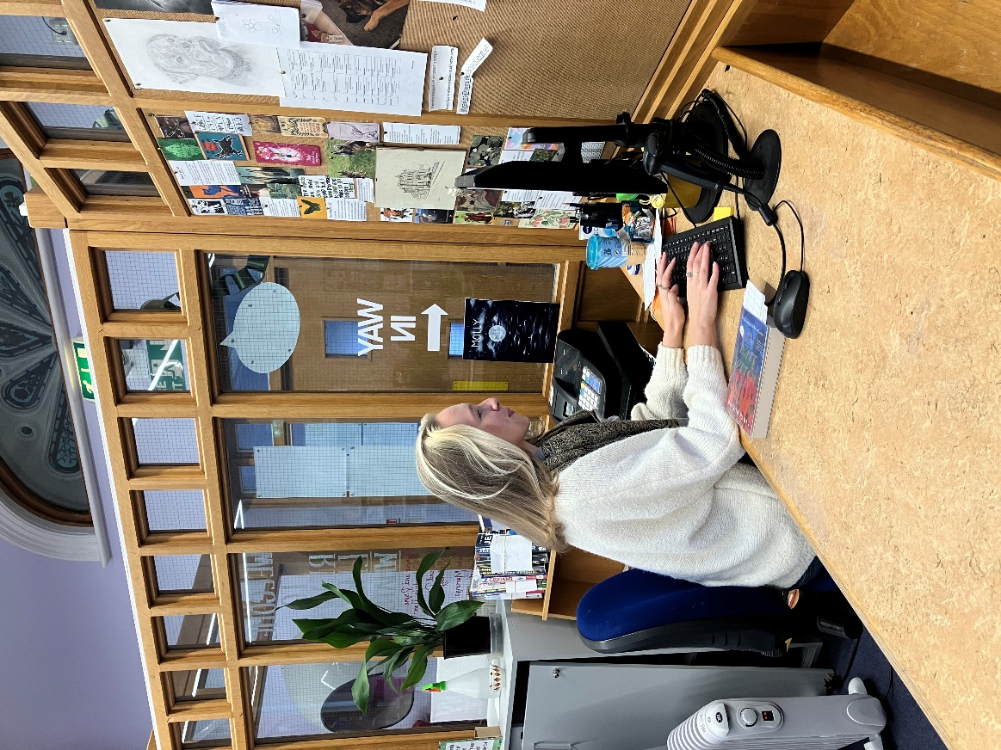

Conclusions

Despite its small size and limited opening hours, Revoe library has a huge impact on the local community, one that is reflected in the social value figures found through the data analysis. Even just focusing on the base figures of £1.3 million per year and a return of investment of 10:1 is a hugely impressive outcome that highlights not only the incredible value Revoe Library provides for the community, but also it’s potential. This economic value and the esteem it is held in by the regular users is all done in half the week, by a small number of staff. The potential of what it could do with increased hours and more staff is very exciting.

From an economic point of view, the largest gains in value after all other services are provided at Revoe, come from health and loneliness impacts of the library. These are harder to quantify depending on specific needs of individuals, but it seems that the provision of these sorts of initiatives make a palpable difference to local health and well-being.

This tallies with the responses to the qualitative work, where a big focus was placed on the feeling of community and social connection that arises from the library. From the seemingly small things such as the consistent presence of specific staff members to communal events such as the Christmas light switch on, to bigger undertakings such as the art group where members can socialise, learn a new skill and progress together. Indeed, the only responses that were not effusively positive in the surveys were about wanting more. More events, more groups, more activities, more digital support, more study space.

It is also worth highlighting the importance of the library in these values. Whilst a lot of these offers could occur at different venues, the benefit of the library is the stacking of values. For example, if the art group was to happen at a community centre it would still provide a benefit, but that value is more likely exist on it’s own. Whereas in the library, attendees can combine their art session with book borrowing or using the computers to book a gp appointment. It is these through 2nd and 3rd order values that the library excels as a space. People can come in and stay as long as they need and do what they need to, they don’t need to get out before another class arrives or buy anything.

Unusually for the library sector, given the long period of staffing related cuts it has faced, Blackpool Libraries has been very stable, undergoing restructures across 2-2 and 2022 but facing no significant staff reductions since 2017. Whilst this has proven operationally difficult at times it has provided relative stability. For the library service, this work has been an ideal opportunity to be proactive, performing an evaluation with a view to being able to celebrate what it does well and look at what could be done next. As service mapping and highlighting potential new offers has always been an intended outcome for this project, I have included a list of recommendations for Revoe Library based upon the insights from both the data and the community, recommendations for progress rather than reinvention.

As the library sits in an area of high need, with high levels of mental health issues, extremely low life expectancy especially for men and high risk of digital exclusion, it is a community that must often feel undervalued. As this report has shown the library does vital and tangible work to serve the community, so to improve it and invest in it is to invest in the community and make them feel valued. The overriding demand is for more, and the more the library can do the more people it can help. The good the library does, and can do more of, is perhaps best summed up by this comment from our first focus group: ‘the library is so important for helping people with isolation, loneliness and their mental health, [of the library and it’s staff] they help people before they reach a silent crisis.’

Recommendations

- Increased opening hours and more staff. With the addition of 2.5 FTE staff members, Revoe could be open full time and have consistent dedicated staff, alongside staff from elsewhere in the service. This would be incredibly important for the community aspect of Revoe. The current staffing costs at the library are £52,478.80 which includes two FTE staff and manager hours inclusive of tax and pension contributions. The addition of 2.5 FTE staff would increase staffing costs to over £105,000 alongside a slight increase in running costs. However given the high level of value the library produces on minimal staffing whilst open half the week, it is extremely probable that the value would increase in tandem, increasing the £1.4 million base figure to well above £2 million. This seems especially likely given the ambition of the Revoe staff in their desire to increase the offers for the community.
- More digital support. This could include different levels of support, from the base level of librarians helping individuals when needed, to drop-in sessions with a dedicated IT support, to specific sessions on different topics from research skills to using resources such as accessing council resources.
- More health partnership work. Revoe already has a good relationship with the local NHS but seeing how many use the library in support of their health shows how an increase in offers, from awareness campaigns, drop in sessions to even offering some intervention steps such as blood pressure monitoring, will benefit both the library, the health service and, most importantly, the community.
- More creative activities for adults. The art club has gone down extremely well with regular users having responded well to the structured, skill-based, group approach. This has a myriad of benefits and similar groups or activities can provide even more to both current users and potential new ones.
- More mental health based offers. This could include both direct and indirect offers. Direct offers could include partnership with mental health providers in the area, such as a mental health group within the safe space of the library which might make things easier and more accessible for people than having to travel to different, less familiar sites. Indirect offers could include shared reading groups that have a ‘bibliotherapy element.’
- More council support for the community. From its use in the regeneration consultation to staff supporting users to access council services, a more formal version of partnership working would benefit the community, the library and other sections of the council through increased engagement from the accessibility it would provide. This could include improved information sharing with library staff on initiatives and resources, increased signposting and drop-in sessions for specific council services.
- More community mapping. Before the enforced closure for the by-election the library was increasing its outreach to the underrepresented communities in the area. Increased staffing levels and opening hours could allow for a renewed focus on this work by connecting to specific groups in the area or the hosting of specific events or activities aimed at these communities and their needs.

