t
Text here.



Novels that shaped our world:
Arts Council England partnership project with BBC Arts
Final evaluation
July 2022

Contents

- Introduction
- Who engaged with the activities
- Why did they engage
- The impact on participants
- Interaction with BBC Novels content
- Partnership working
- Successes and challenges
- Conclusion
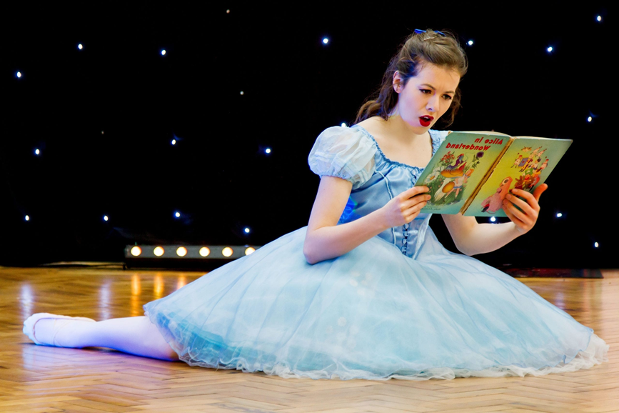

Introduction

In 2019, BBC Arts launched 100 Novels that shaped our world, a list of 100 genre-busting novels written in the English language in the last 300 years selected by a celebrity panel. The list is divided into 10 themes, each with 10 books, which reflect the ways books help shape and influence our thinking.

To support the campaign, Libraries Connected worked with the BBC to develop a year-long project to enable library services to develop activity and events spring boarding off the 100 Novels list to spark national debate around novels and celebrate the joy of reading. As part of the programme, 54 library services across England ran book-related cultural events, working in collaboration with BBC local radio, partner organisations and communities.

The project was supported through the Ats Council England National Lottery Project Grants.

Aims
- To increase universal engagement with reading, to inspire people who are not regular readers to pick up a book and to tempt existing readers to try something new
- To introduce reading and libraries to new and diverse audiences particularly areas of deprivation, BAME communities and rural localities.

It also aimed to support library staff development, in particular skills in digital applications and community and reader engagement. Partnering with local community, arts and cultural groups were seen as key to the success of the campaign.

The project started in January 2020 with events taking place at several libraries during the first two months of the year. However, when restrictions were imposed across the UK due to the pandemic, libraries’ plans had to be redrawn. With flexibility from the primary funders, Arts Council England, the campaign was extended a further 12 months, until September 2021. The campaign culminated in a celebratory event at the British Library in October 2021, and some legacy projects running until Spring 2022. After a competitive tender process Hugh Hope-Stone of Hope-Stone Research was commissioned to evaluate the programme and he was part of the project from the outset.

In total 54 library services took part in the project, running over 200 events.

The project was led by Libraries Connected, with each participating library service free to design their own creative activities, based on local needs and interests. The only requirement was that these should be inspired by the BBC’s 100 Novels that Shaped our World list, and that they had to target diverse communities who were less engaged with libraries.

The evaluation

This evaluation report draws upon findings from HOPE-STONE Research and data gathered by the project team. Data for the evaluation was collected via four online surveys:
- A short audience/participant survey with 370 responses
- A short audience/participant survey with 370 responses
- A longer audience/participant survey with 96 responses
- A partner survey with n=69 responses working with 37 library services
- A library service survey with 74 responses from 42 library services.

Participant survey responses have been combined, creating an overall sample size of 466 representing around 50 events and activities run by 29 library services.

The survey feedback has been complimented by feedback from video interviews, school visit comments and photos and other anecdotal evidence shared by participating libraries.

- Who engaged with the activities?

Digital vs physical library events
Digital | Physical | Both
20 | 17 | 16

- Number of people engaged. At least 12,350 participants in their events with a further 504,692 reached by social media
- Gender. Three in four of those attending were female.
- Ethnicity. One in four of those attending were non-White British or Irish, a much higher proportion than in the population as a whole. Almost half of reporting libraries said their audience included people from Asian communities, with a third reporting Black African or Caribbean audiences.

Reported proportion of participants by ethnicity

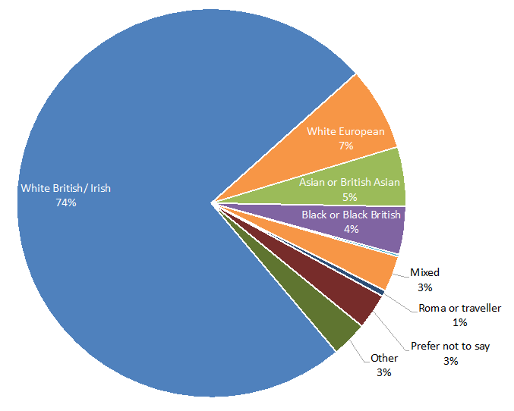

- Age. There was a broad range of ages but with a skew towards a slightly older, 45+ audience. The least represented were young people 16-24.
- Reading interest and ability. The overwhelming majority of those responding to the survey said they both enjoyed reading and were good readers. However, there was still a substantial minority who either only read when they must (one in eight) or find reading harder than other people (one in six).

- Why did people engage?

‘After lockdown… we were eager to take part in something social.’ Participant

In the survey conducted by HOPE-STONE Research:
- Four in five people attended events for themselves, the remainder on behalf of others, e.g., children or people they were responsible for. The primary motivators to attend were that it would be enjoyable (three in five) and/or that someone they were with could learn something new (one in three).
- A third said they listened to a BBC radio programme connected to the campaign, while a quarter had watched a TV programme.
- The primary motivation for attending was that they thought the activity or event would be enjoyable, three in five said this was a reason, followed by the hope that they or someone they were with could learn something new (one in three):
‘I wanted to learn about the history of Bristol, including power and justice, and the significance of the Black Lives Matter protest in Bristol including the toppling of the Colston statue.’ Participant
- For others it was an opportunity to have interaction in person after lockdown:
‘Something a bit different, not something I’d experienced before, theatre in a library …and interesting topic, an interesting title, to see some live theatre because the last 18 months we haven’t really seen anything at all.’ Participant

- The impact on participants

- 90% said they enjoyed the event or activity they attended or took part in, describing it as ‘fun, interesting and informal’
- 88% agreed they had learnt something new from participating
- 74% agreed that it had made them want to read more novels or stories
- 28% of those who find reading hard said they had changed their view about reading stories
- 73% libraries reported new or existing users using libraries more or for different reasons than before
- 66% of libraries reported new or existing readers joining in other events or activities linked to reading elsewhere
- For some, participating made them think about the value of the library and in some cases how they had forgotten about what it can offer. Taking part re-kindled their interest and willingness to engage.
‘I don’t go to the library but I should, I was looking at the books on the shelves and thinking I should read some of them…you get so used to being able to buy things…you forget to use the library…I do have a library card but I don’t remember the last time I took a book out of the library.’ Participant
- The activities inspired some who were not regular readers to pick up a book as a result of participating
‘Some of the children who attended the family events were reluctant readers but took great pride in taking their book home. One mother reported that her son, aged 6, had read Three Little Vikings to his grandad as soon as he got home.’ Library

- Interaction with BBC Novels campaign

The evaluation indicates that engagement with BBC content was high among participants, especially considering the gap between the broadcasts and many of the events and activities. Just over a third of participants said they listened to a BBC radio programme connected to the campaign, with a quarter saying they had watched a TV programme.

Have you done any of the following in the last 12 months?
BBC activities | %
Listened to a BBC radio programme about novels | 34%
Watched a BBC TV programme about novels | 25%
Looked at BBC online content about novels | 20%
Followed BBC content on social media about novels | 17%
N=65

- Partnership working
Working with community partners
Libraries worked with multiple cultural and community partners over the campaign period. Partners included:

- Schools
- Authors
- Arts organisations
- Dance companies
- Story tellers
- Charities
- Theatre groups
- Universities
- Community groups
- Refugee support groups
- Film makers
- Illustrators
- Artists
- Museums

Over half of partners provided content and activities, one in five were responsible for promoting the event, while a quarter did both.

Two in three of libraries worked with partners at least some of the time to reach those with limited access to books and reading and 89% of libraries considered themselves to have been at least partially successful in reaching their target audiences.

Partners brought expertise, quality events and capacity to libraries:
‘Expertise – our partners had a wealth of knowledge relating to games, storytelling and learning…Quality – being able to commission work and pay facilitators ensured that our activity programme was high quality.’ Library
‘It increased the expertise available to our team to support the project and enabled us to work sensitively and appropriately with very vulnerable audiences.’ Library
‘Commissioning professional and academics to produce the podcast episodes resulted in a professional and high-quality finished product.’ Library
Partners helped libraries reach new communities who had not previously engaged with libraries.
‘The partnerships we have made as part of the project has given us greater depth of understanding and insight into the lived experience of our target demographic.’ Library
‘Understanding the challenges faced by our partners and those they are working with as been a humbling experience.’ Library
‘By continuing some of the work in a library setting, front-line library teams have also been given an insight into the very real experiences of the young people, newly arrived and unaccompanied into the area. It has helped foster empathy and understanding, which we hope will transmit to the wider community. It has also helped put 'libraries on the map' as far as these organisations go and perceptions of us as a friendly, welcoming and helpful service which can serve their community’s needs.’ Library

Partners also reported benefits from participating in the 100 Novels campaign by:
- Being introduced to new audiences.
- Building partnerships with libraries and other organisations or authors.
- An increase in confidence and skills
- A change in perspective or provided inspiration for new work.

Challenges expressed by some partners:
- Logistics such as tech, Covid-19 restrictions, time and funding limits
- Variable quality of marketing materials
- Difficulty in communications
- Poor perception of libraries among target audiences made them resistant to taking part.

BBC partnership
BBC Learning provided a range of support and opportunities for libraries, ranging from broadcast airtime to digital content and resources to interactive technology. Despite the disruption caused by Covid-19, many libraries were able to benefit from this support to develop their own activities.

Can you provide any examples or evidence of the value to your library or staff of BBC involvement?

BBC activity | % Mentioning its use or value
Training for library staff | 68%
Programming on TV and radio | 61%
Digital content and resources | 48%
Social media activity | 48%
Provision of interactive technology* | 29%
*This element of the support was compromised due to Covid-19 limitations.
N=31

- Training for library staff
‘BBC Digital Cities programme has been invaluable to upskilling staff and informing on best practice.’ Library
‘The webinars throughout lockdown gave a fantastic insight into how we could deliver our services in alternative ways.’ Library
- Programming on TV and radio
‘One of our featured books was Cold Comfort Farm, which the BBC conveniently showed about two weeks before the event.’ Library
‘Some of our displays tie in with current programmes as they attract visitors in the library to go to them.’ Library
- Support from BBC local radio.
‘We engaged with BBC Hereford and Worcester at campaign launch and had a lengthy chat about reading and novels on the evening show with Kate Justice.’ Library
‘The campaign also helped cement a relationship with BBC Radio Tees presenter Rachel Teate. She is very enthusiastic about promoting books/poetry/libraries and will be an invaluable contact moving forward.’ Library
- Digital content and resources
‘Very helpful to have branded content and resources to bring focus to the campaign at a local level, e.g., creating eBook collections to match with themed titles.’ Library
‘Accessibility of BBC Archives resources - to promote on social media.’ Library
‘The BBC 100 novels website was very useful for images and blurbs of the books on the list and an easy way to share content for our library users.’ Library

- Successes and challenges

Switch to digital
Just two library service had started delivering events in 2020 when the pandemic took hold and the services had to quickly change focus and switch to online delivery:
‘This was the first online event that the library service had ever delivered and was a trailblazer for us, paving the way for delivering events over the Summer for children.’ Library
‘This partnership allowed Kent libraries to trial an event that was accessible to the audience solely online. It has added to the skills of our library staff, in terms of both putting on a live performance and the digital side of showing the performance and monitoring online engagement of the event.’ Library
‘Authors into Schools Running the sessions online via MS Teams meant we could reach a wider audience from all across the borough and students and teachers were able to meet the author, even when they were at home or school as we ran the sessions during National Lockdown.’ Library
‘For library staff –this provided a reason to build up skills in how to record on Zoom, edit videos, create trailers, the importance of marketing. These skills were then used for other events.’ Library

Many libraries wish to continue to run a digital offer alongside in-person activity and to see libraries develop as cultural spaces. However, libraries also recognise that moving online also brings challenges as well:
‘Promotion was really tough. It was mainly done digitally, which makes it very difficult to reach excluded groups.’ Library

- Digital level of engagement was less than if it had been in-person, even more so if the activity was pre-recorded or via social media rather than livestreamed
- Technical problems with connectivity, video and audio led to audience drop out.
- Those who are hard to reach are often digitally disconnected
- Constantly changing restrictions due to Covid-19, meaning activities had to be cancelled, amended, or rearranged in some way.
‘The changing government advice regarding Covid closures meant that we were forced to edit our plans several times.’ Partner

Re-connecting with communities
The novels project gave libraries the opportunity to re-establish in person events as soon as it was safe to do so and allowed them to sensitively respond to the needs of diverse communities:
‘This was our first in person event and it helped us gain confidence to hold activities again.’ Library
‘The support provided for the event was massively welcomed, the fact that we held an in-person event when we were just emerging from lockdown was a great support to the library in coming out of Covid restrictions.’ Library
‘The young people were very engaged with Alison Cope the anti-violence campaigner as she lost her son to knife crime so gave a very personal story. The young people had been reading extracts of the book, The Knife that Killed me, prior to the session so were able to link fiction with real life. Alison's son was only a couple of years older than the group of young people and was a successful DJ, so the young people connected with her story.’ Library

Although broadly very successful, libraries recognised that the audiences they had set themselves the task of reaching sometimes made promotion difficult. In some cases, building up trust and a relationship were considered important to achieve the right results, and one-off events could not achieve this:
‘It was quite a challenge to break the barrier for homeless people to come into the library space. This was mainly for people’s own perceptions of what libraries are like, but also, because of the nature of being homeless and in crisis usually, so hard to engage with other things/events.’ Library
‘We struggled with how to break beyond our existing social media audience to advertise to and reach a wider audience.’ Library
‘It was hard to target just one particular audience, men, as it was advertised mainly through library social media and as they don’t seem to use the library service in the same numbers as women possibly less likely to see this.’ Library
‘You need to build an audience over a series of events, especially when introducing something new such as Story Readings to people disengaged from reading.’ Library

There was also reflection on the issue of charging for events:
‘The workshops were the least successful. People had booked on Eventbrite, but many didn't attend. Perhaps we should have made a small charge for tickets. It seems that people are happy to book free events and not attend.’ Library

- Conclusion

The 100 Novels campaign partnership between Libraries Connected, BBC and ACE and multiple schools, community, arts and charitable organisations led to 18 months of events across England that engaged many thousands of people in reading and linked activities despite the most serious pandemic for 100 years.

Libraries were able to re-imagine what the 100 Novels events should be and to develop and deliver both online and in-person. This created a very high level of participant satisfaction and an opportunity for libraries and partners to develop news skills and capacity for future potential audience engagement.

As with many Covid-19 hit public engagement programmes, this project demonstrated that while online delivery is not the panacea to a lack of in-person activity, it can play an important role in providing content to those who cannot physically access libraries and/or wish to engage in a digital manner.

While the activities in this project did attract core readers, they also successfully reached new audiences supported by new and existing partners that were well placed to engage with and encourage those less familiar with libraries to take part.

We are hugely grateful for the partnership between Libraries Connected, The BBC and the support of our other partners The Reading Agency, The British Library, CILIP and The Publishers Association. We also would like to express our appreciation to the 54 library services who delivered The Novels that Shaped our World libraries campaign despite facing some of the most challenging circumstances in living memory.

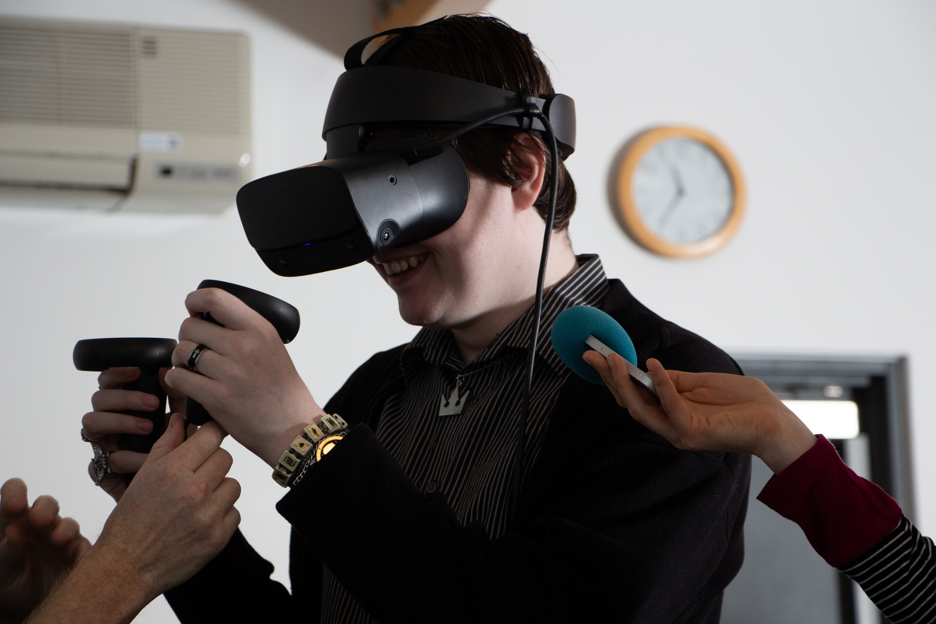
X
© Libraries Connected 2022

Email:
info@librariesconnected.org.uk
Twitter:
@libsconnected
Or join our mailing list at:
librariesconnected.org.uk/signup

