A guide to Single Sign On

Produced by Society of Chief Librarians & Jisc

Version 1.6

23rd April 2018

Introduction

This guide is intended for public library staff and Heads of service to help them set up Single Sign On for their library service. Jisc and SCL have worked together to make this process as straightforward as possible but if there’s anything we’ve missed please let us know.

You’ll find a background video about Single Sign On here: https://youtu.be/PNAyGwaAjt4

Have a look through the guide and if there’s anything you don’t understand then please email liberate@jisc.ac.uk

Jisc are world leaders in access management for resources and provide the Single Sign Solution through their Liberate service. We have deliberately left out a lot of the technical jargon in this process. But if you are interested please head over to www.jisc.ac.uk/liberate to get a much more technical detail and background.

Overview

Overview of the sign up process.

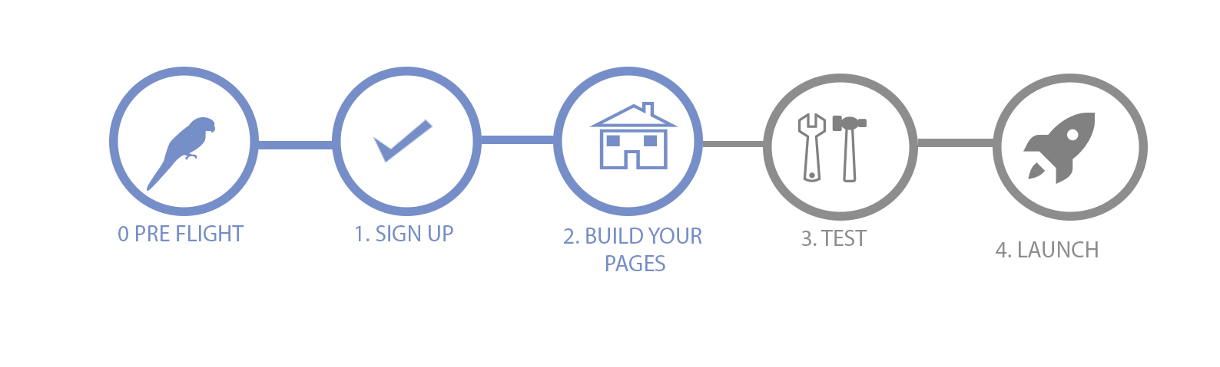

0. Before you start - Preflight checks
1. Sign up
2. Build your new eResources pages
3. Test it all works
4. Launch & promote the Service
Extras and your Account

Jisc will do most of the work in the background, but this guide explains the things you need to do to get Single Sign On up and running for your library service.

0. Before you start - Preflight checks.

A. Is your LMS live yet?
Capita, Civica, Sirsi Dynix and Koha from PTFS are all Single Sign On compatible ( Axiell is in development as at 23/4/18)
If your LMS isn’t listed here, please email liberate@jisc.ac.uk and they’ll talk to your LMS provider for you.

B. What eResources do you have?
Check how many of your eResources are Single Sign On compatible. (email liberate@jisc.ac.uk a link to your eResources page and they can check for you) Currently the titles we know to be compatible are:

19th century newspapers
American National Biography Online
Artemis Literary sources
Britannica
British newspaper archives
Credo
Custom journal
Custom newspapers
Ebsco
Gale News and Reference collection
Issues online
JSTOR
Keynote
Lexis Nexis
Marketline
Mint
Mintel
News bank
Oxford Art Online
Oxford Dictionaries online
Oxford Dictionary National Biography
Oxford English Dictionary
Oxford Language
Oxford Music Online
Oxford Reference Online
Public info online
Thomson
Times Digital Archive
UK Press Online
Very Short Introductions
Who’s Who
World Book

This list is being updated all the time and Jisc are actively adding new titles all the time.

C. Check the price
Jisc charge an annual tariff for Single Sign On using the Jisc band system used for other eResources. If you email liberate, they will send you a quote. The price covers all technical work to get you up and running and on-going technical support to Libraries. Support and assistance will also be provided to help Libraries make best use of the service, and to help libraries support their users.

If you’re happy with the eResources available and price then go to step 1.

1. Sign up

Sign up to Liberate service
Liberate is the name of the service that gives you access to Single Sign On.

When you send an email to Liberate@jisc.ac.uk they’ll send you a Sign up for Liberate form for the Single Sign On Service Jisc need the details to make sure that it's registered correctly.
Note: When you get to 'Services required', you need to tick the box for UK Access Management Federation i.e.

https://www.jisc.ac.uk/forms/sign-up-for-liberate

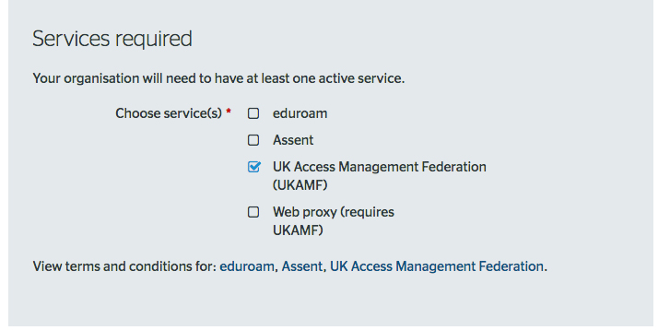

Note: there will be a tick box for Single sign on but (as at 28th March) it isn’t there yet.

If you haven’t already, email Jisc a list of your eResources. They’ll send you a list of Single Sign On compatible resources.

Single Sign On Links
To get you setup you can ask your publisher or Jisc to send you the special SSO weblinks you’ll need for your eResources page and your catalogue. If you need MARC (.mrc) files for your catalogue get in touch with your publisher

Return the forms to Jisc
After you’ve completed the form print it on headed paper, get it signed by the authorised signatory (usually but not always your head of service) then return to Jisc, by post or scan and email it to liberate@jisc.ac.uk.

What happens next
Email your publisher and tell them that you are switching over to Single Sign On, or email liberate@jisc.ac.uk with your contact at the publisher and they’ll inform them. The publishers have to switch your resources over to Single Sign On for them to work correctly.

Tip: once you are live, you may want to ask your publisher to turn off IP authentication for that resource. This will help

- customers get exactly the same experience in the library as they’ll get at home,
- raise staff awareness of Single Sign On and get them used to it.

*Before Single Sign On IP Authentication was how publishers knew you were licensed to used their eResources.

When you receive a 'Congratulations It's Live' email you can start to build your new eResources web page.

2. Build your new eResources pages
Once you’ve received your ‘It’s Live’ email from liberate@jisc.ac.uk you can begin building your new pages

You should have received your new eResource links from the publisher or Jisc. You’ll need put these in wherever your existing eResource weblinks are on your website. It’s a good idea to build a new SSO page, that customers can’t see. It means you can do your testing without affecting your existing services. It’s also much easier to carry out testing and you can also do a soft launch publishing the page as a beta version to customers.

Here's how some other libraries have laid out their pages:

Bournemouth Libraries Bournemouth eResources . (Bournemouth also added a What is Single Sign On? Page. Solihull Libraries created a Virtual reference library page

Single Sign On web links
For Single Sign On to work you need to use WAYFless urls instead of the links you currently use. A WAYFless url is a longer url that sends the customer to the right place to sign in (if they aren’t already) and then straight on to the eResource.

Tip: if you aren’t already signed up to LIS-E-Resources this is an excellent time to sign up. Lis-E-Resources is where other library colleagues post hints & tips, detail any outstanding issues, or changes publishers are thinking of introducing.

What happens next?

Let us know when you’re done and we’ll help you Test it all Works.

3. Test it all Works

The best way to test is using your separate webpage, hidden from public view. You could publish a page that isn’t linked to from any of your other webpages. Having your Single Sign On eResources on one page will make it simpler to check they’re all working properly.

- Test each resource in turn, log in to the first one, then check all the others log you in automatically.
- In a new session (incognito or inPrivate window) test that each title takes you directly to your Single Sign On page.

Tip: Bournemouth tried testing in the library (using software to hide the fact that they were in the library) but it didn’t always work. The only real way to check was to get out the building and test in a nearby café with Wi-Fi

If you do see any error messages, paste them into an email and send it to liberate@jisc.ac.uk.

4. Launch & Promote the Service

Tips
Create an ‘easy url’ for use on posters and twitter, for example Bournemouth Libraries asked their webteam to change this:
https://bournemouth.gov.uk/Libraries/LibraryServices/cyberlibrary-eresources/cyberlibrary-online-resources.aspx
to this
bournemouth.gov.uk/eResources
It takes customers to the same place but is a lot easier to type and remember.

Promoting the service takes time but try a combination of posters, flyers, website pages, and social media. On twitter #eResources is pretty popular but it’s worth promoting to specific groups and subject e.g. job clubs, reading groups, children doing homework etc. Other avenues to try are
- write articles about the new service for newsletters, either your own or offer them to schools and parishes who are often looking for content for their magazines.
- Use the active partnerships you will have in your library service such as with Citizens Advice, Job Centre plus and local groups and organisations. Spend a little time explaining Single Sign On to these groups and they will promote it for you.

If you have any Questions
If you have any questions about the joining process or about Single Sign On please email liberate@jisc.ac.uk

End

