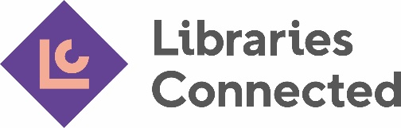
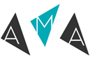

Inclusivity and Audiences Day 2022
Libraries Connected Bursary Application Form
Libraries Connected will provide two bursaries that cover the full cost of Inclusivity and Audiences Day 2022.

These bursaries are available to people working in public libraries in England, Wales, Northern Ireland and the Crown Dependencies.

Applications are open to both AMA members and non-members, including those who can no longer afford to take part in AMA events due to Covid-19.

Although it isn’t essential, we would welcome applicants who fit one or more of the following criteria:
- Individual from a diverse background (including, but not limited to, the 9 protected characteristics identified by the Equality Act 2010 - age, disability, gender reassignment, marriage and civil partnership, pregnancy and maternity, race, religion or belief, sex, and sexual orientation).
- Individual working in a geographical area with high levels of deprivation (by this we mean due to rural isolation or low socio-economic communities for example).
- Individual who works primarily in the Welsh language, or who works for an organisation working predominantly in the Welsh language.

Please note:
- We will only award one bursary per organisation
- Recipients of the bursaries will be asked to provide informal feedback on their experience to Libraries Connected.
- The AMA will request successful applicants to provide feedback, that may be used for marketing purposes, on their experience Inclusivity and Audiences Day.

How to apply:

Complete and submit the application form to helen.drakard@librariesconnected.org.uk by 5pm on Monday 11 April 2022.

If you have any queries about these bursaries, please email Helen Drakard helen.drakard@librariesconnected.org.uk

Next steps:

Libraries Connected will assess each application aim to respond by 11 April.

For the applicant to complete:

- Your contact details

Name & Job Title

First Name:

Last Name:

Job Title:

Address

Organisation:

Address Line 1:

Address Line 2:

City:

Postcode:

Email:

- Are you an AMA member?

Yes
No

- How long have you worked in the cultural sector?

Up to 1 year
Up to 5 years
Up to 9 years
Up to 14 years
15 + years

- Number of dedicated marketing / audience development staff in your organisation:

No dedicated person
One
Two
Three
Four or more

- Please indicate any criteria which apply:

An individual from a diverse background.
An individual working in a geographical area with high levels of deprivation.
An individual who works primarily in the Welsh language, or who works for an organisation working predominantly in the Welsh language.

- Please state your reasons for applying for this bursary (up to 200 words) i.e. why would you and/or your organisation benefit from Inclusivity and Audiences Day:

