Libraries Connected E-Learning

Libraries Connected is committed to ensuring that people who work in libraries have the tools needed to help library customers access life-critical digital resources.

This Learning platform was developed thanks to support and funding from Arts Council England. Supporting learning is at the core of the library ethos, and Libraries Connected wants to make sure that all who work in libraries are confident and competent in delivering this fundamental offer to our communities.

All of the e-learning courses can be accessed via this web link https://lc.learningpool.com/

Register and Login
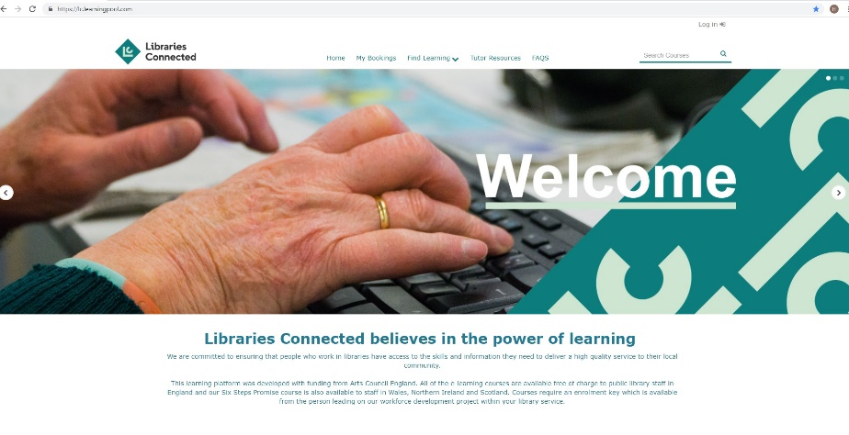
Before you can access the
e-learning courses you need to click ‘Login’

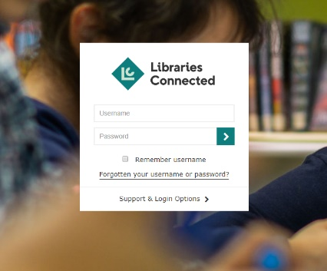
If you have already registered with Learning Pool you can login using your username and password.

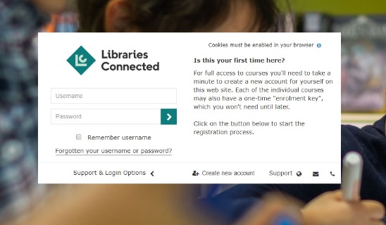
If you haven’t registered you can create an account by clicking on ‘Support and Login Options’

Then ‘Create new account’

Accessing a Course

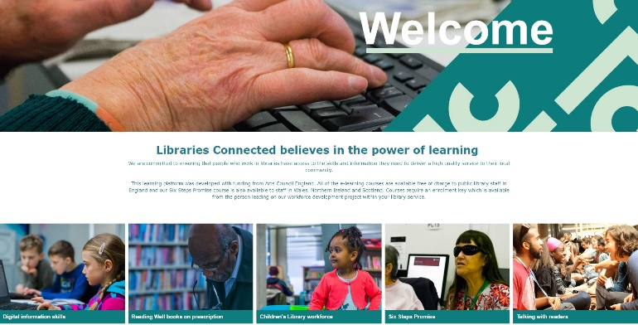
Once you have logged in you can select the course you’d like to do from the bottom of the home page.

If this is the first time accessing a course you will be prompted to enter an enrolment key which you can obtain from the person leading on this project in your library service or Libraries Connected.

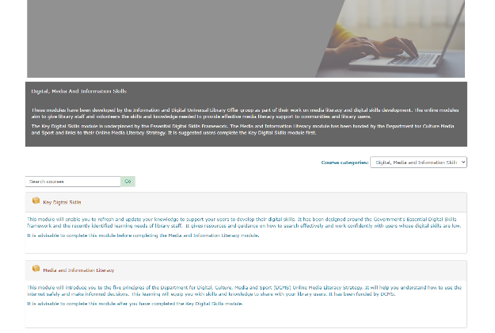
Once on the course page you can access the training you’d like to do by selecting the relevant module form the list

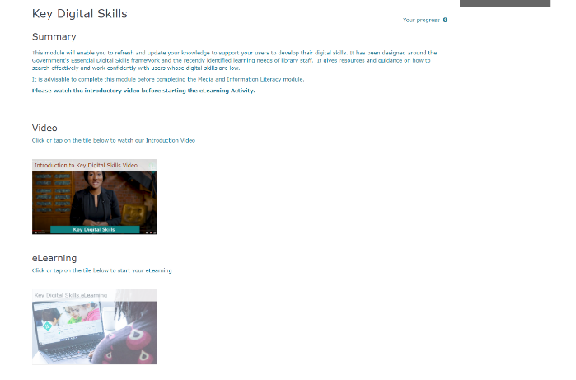

Then click on the links to launch the
training elements such as video, e-learning or feedback.

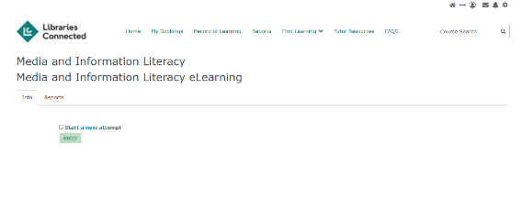
Click ‘Enter’ on the next page.

If the course page doesn’t launch automatically you may get this screen and need to click to launch manually.

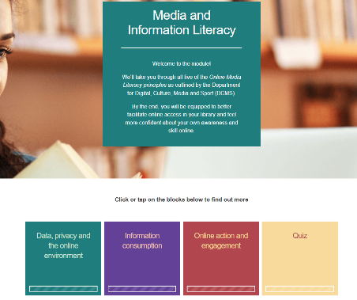
The course page should then launch in a new window and you can select a section by clicking on them and work your way though.

The bars at the bottom of each section box will show your progress by changing from white to coloured

When you close the course window you may see this message and you need to wait until your progress has been saved and you are redirected back to the earlier launch screen before closing the second internet window.

If you have any technical difficulties, please contact the Learning Pool help desk on 0345 074 4114 or email: support@learningpool.com

For any other comments or enquiries contact info@librariesconnected.org.uk

Libraries Connected Courses

Leadership: Leading Libraries
This 'Leading Libraries' series forms part of the 'legacy' of that programme, offering a wide range of online materials for anyone within the libraries service who wants to develop their leadership practice, regardless of role or seniority.

The Leading Libraries series covers four leadership capabilities for collaborative and distributed leadership practice. These were developed from the core ideas covered in 'The 21st Century Public Servant' [Needham, C., & Mangan, C. (2014). The 21st century public servant. Birmingham: University of Birmingham].

The four capabilities are:
- Leading for Resilience
- Leading for Dialogue
- Leading for Inclusion
- Leading for Innovation.

The materials were produced in 2020/21 for the Leading Libraries Programme by The Birmingham Leadership Institute at the University of Birmingham. Leading Libraries was commissioned by Libraries Connected in partnership with CILIP (including the BAME network), CLOA and LGA. The Leading Libraries training is supported by Arts Council England through its National Lottery funded Transforming Leadership programme.

Digital, Media and Information Skills

This course is made up of two modules which have been developed by the Information and Digital Universal Library Offer group as part of their work on media literacy and digital skills development. The online modules aim to give library staff and volunteers the skills and knowledge needed to provide effective media literacy support to communities and library users.

The Key Digital Skills module is underpinned by the Essential Digital Skills Framework. The Media and Information Literacy module has been funded by the Department for Culture Media and Sport and links to their Online Media Literacy Strategy. It is suggested users complete the Key Digital Skills module first.

- Key Digital Skills - This module will enable you to refresh and update your knowledge to support your users to develop their digital skills. It has been designed around the Government's Essential Digital Skills framework and the recently identified learning needs of library staff. It gives resources and guidance on how to search effectively and work confidently with users whose digital skills are low.

- Media and Information Literacy - This module will introduce you to the five principles of the Department for Digital, Culture, Media and Sport (DCMS) Online Media Literacy Strategy. It will help you understand how to use the internet safely and make informed decisions. This learning will equip you with skills and knowledge to share with your library users. It has been funded by DCMS.

Talking with Readers

Talking with Readers aims to build the skills and confidence of library staff to talk to visitors about reading and books. You will find lots of ideas to help you develop good conversational skills and enrich the experience your library offers to its customers.

The course is aimed at anyone working in a customer-facing role in a public library and contains a mix of online information and practical exercises to work through. We expect each section will take approx. 20 to 30mins to work through online with additional time needed to carry out practical tasks. We wouldn’t expect people to do the course all in one sitting and it has been designed so that people can dip in and out. There are some social media activities for those who have access but you can do the course without.

There is also a section with Line Manager Resources which we would recommend those managing staff who are going to carry out this training look at.

This course has been created for SCL by Opening The Book with funding from Arts Council England.

Culture and Creativity in Libraries

This module will explain why culture and creativity is important in libraries and how to plan a cultural or creative event for your library. You will learn how to select the right kind of arts and artists for your audience, along with how to manage an event on the day, and how to collect and use feedback.

The module was created on our behalf by Creative Arts East with funding from Arts Council England.

Reading Well Books on Prescription

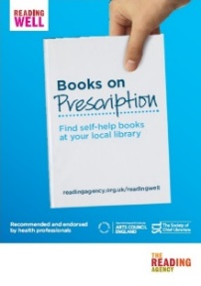
In this module you will find out how to run the Reading Well Books on Prescription scheme in your library. The module aims to support the development of public library champions for the scheme and establish quality standards for local delivery.

The course contains just one module, Books on Prescription, which was developed in partnership with The Reading Agency.

Children’s Library Workforce

Children are essential to the development of the public library service and ensuring that we support, motivate, challenge and inspire them is at the very heart of our role. We need all those working in libraries to deliver a high-quality service to children as they grow and their needs change. We want to encourage staff to be innovative and ambitious and ensure they have the skills they need to make a difference to the lives of children. This course will help all staff to develop these skills.
The course is organised in 4 modules:
- An exciting and accessible environment
- Supporting reading for pleasure, literacy and learning
- Reading, literacy, digital and cultural experiences
- Supporting health and wellbeing

The course has been created by a partnership of ASCEL, The Reading Agency and the Youth Libraries Group and with case studies and contributions from across the public library network.

Vision and Print Impaired People’s Promise – helping people with sight loss

The Vision and Print Impaired People’s Promise module has been designed to help you to help to people who live with sight loss in enjoying their reading and their library service.

The course is split into five short elements:
- What is the Vision and Print Impaired People’s Promise?
- Why is this training important?
- Helping people confidently
- Where can I get support
- Conclusion

You will also learn about sight loss and how it occurs, as well as the importance of reading to people who need extra support and where to look for resources and support.

This course has been devised with the help of Helen Leech and her team in Surrey, Lottie Newmeir-Porter and John Vincent. The course is a partnership project of Share the Vision and SCL funded by the Arts Council.

Other Courses

ACT Awareness eLearning is a national counter terrorism awareness initiative produced by the National Counter Terrorism Security Office (NaCTSO) on behalf of Counter Terrorism Policing (CTP) to protect the UK cities and communities from the threat of terrorism.

The Uncomfortable Series are two modules which explore racial inequality in the workplace. They are aimed at leaders and managers and have been developed by Learning Pool with support from the Centre for Inclusive Leadership, Learning Pool's Black employees, and their Black friends and family.

Mental Health Awareness is a free introductory course from Learning Pool. It will provide you with an understanding of what mental health is, a basic knowledge of some common mental health issues, what good mental health means, some of the therapies and support available and some useful resources. The course should take around 40 minutes to complete.

