Create a Castle

We are going to create a castle in Minecraft that you can customise, but in order to do that we first need to learn about Python and how it works on the Raspberry Pi with Minecraft.
- First we are going to launch Minecraft Pi

Select Menu > Games > Minecraft Pi > Create a New World
You can refer to the Minecraft Pi controls handout if you haven’t played Minecraft on the Pi before.

- To create the castle and run all the other code files we need to use Python.

Press Esc to leave Minecraft and free up your mouse cursor.
Minimise your Minecraft window.
Go to Menu > Programming > Python 2

Go to File > Open > Navigate to the Code Create Minecraft folder and look for and open a file called castle.py
Have a look at the contents of the file. It contains all the code needed to create a castle with a keep and exterior walls. The red text within the code with #hash tags explains what each section of the code does.
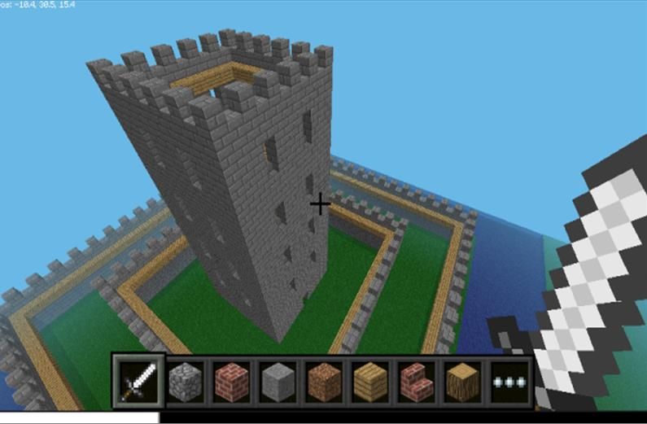

4.)
To run the code press F5, another Shell window will appear. If you have written your code correctly it should say RESTART.
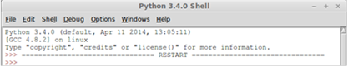

Go back to your Minecraft game and see what has happened. You may see a black screen and it may take up to 20 seconds to complete and your castle to appear depending on the Pi model you are using.
