Universal Library Offer Virtual Seminar Programme

10.00 Introduction from Ayub Khan, Libraries Connected President
10.10 Wider Picture from Luke Burton, Arts Council England
10.20 Reading Update from offer lead Sarah Hassan
10.30 Ask for a book – Rachel Van Riel
11.00 Reading Related Flash Films
11.10 – 11.30 Break
11.30 Children’s Promise Update from Annabel Gittins
11.45 Health and Wellbeing Update from Sue Ball
11.55 Dr Tola Dabiri National Lead for Arts and Culture, National Academy for Social Prescribing
12.25 Health & Wellbeing Flash Films
12.35 – 13.55 Lunch Break
13.55 Vision and Print Impaired People’s Promise update from Mark McCree, Share the Vision Chair
14.10 Information and Digital Update from offer lead Dave Lloyd
14.20 Libraries Connected and Good Things Foundation research project into digital inclusion – Leila Baker and Wendy Sugarman
14.50 Information & Digital Flash Films
15.00 – 15.15 Break
15.15 Culture and Creativity Update from offer lead Michelle Alford
15.25 Art of Libraries: An Introduction to libraries as performance spaces - Owen Hutchings, St Helens
15.45 Engaging audiences Louise Yates, Director, Back to Ours
16.05 Culture & Creativity Flash Films
16.15 Arts Council England Project Grants from Kate Earl & Emily Jewell
16.25 Closing Words from Isobel Hunter
16.30 Finish

Keynote Speakers
Rachel Van Riel, Director, Opening the book
Rachel is a passionate advocate for public libraries as well as an occasional ‘critical friend.’ In founding Opening the Book, Rachel brought together her experience of working in three different sectors:
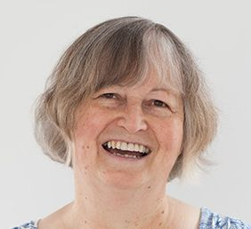
- in university and adult education, where she learned that people have a hunger to be stretched;
- in community arts, where she found that everyone enjoys expressing their own creative views;
- and in libraries, where she discovered the best community-based, flexible institutions for the kind of audience development work she wants to do.
Opening the Book is now an independent, creative organisation helping libraries to deliver 21st-century services. The company has provided training in reader engagement for more than 20,000 library staff over 5 continents, as well as ground-breaking designs for library interiors in the UK and North America.
Rachel is excited to be developing the Ask for a Book project with a consortium of 15 library services in England led by Leeds.
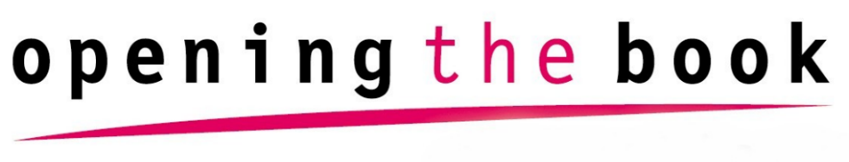

Dr Tola Dabiri, National Lead for Arts & Culture, National Academy for Social Prescribing
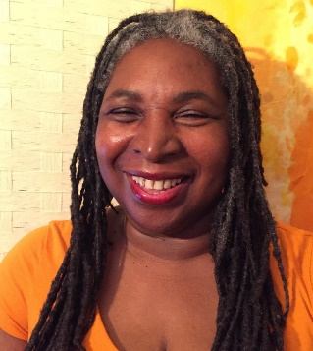
Tola has worked across the cultural sector since 1995, beginning her career in public libraries and archives. She has also worked at the Museums Libraries and Archives Council and The National Archives, and the UK Centre for Carnival Arts, and she has developed and managed a number of successful projects including Carnival in a Box (carnivalinabox.co.uk), Fundraising for Archives for The National Archives, and UKCCA’s HLF funded Carnival Archive Project, (www.carnivalarchives.org.uk).
Tola was awarded a PhD from Leeds Beckett University, for her research looking at orality and the intangible cultural heritage of British Caribbean Carnival. Tola is also a consultant in the cultural sector, specialising in project management, equality and inclusion, and fundraising.

WSA Community Consultants specialises in community development, meaningful participation and social inclusion. We have a strong ethical approach and values, with an emphasis on being inclusive, respectful and accessible. Find out what we’re all about – download our WSA Annual Review 2022 (wsacommunity.co.uk)

Wendy Sugarman is the Company Director of WSA Community Consultants and brings over 30 years’ experience of youth and community work. The breadth of her experience encompasses research, monitoring and evaluation, community development, project management community participation, equalities and diversity and project management. Wendy is an effective and efficient manager and facilitator, building mutual trust by practising open and clear communication. She is a strong advocate of collaboration and co-creation, evidenced by projects conducted alongside communities and stakeholders in the UK and abroad. Recent projects include leading on the Maternal Mental Health Alliance Everyone’s Business evaluation; facilitating a community led panel to build community leadership for the Grenfell community in relation to the distribution of the Grenfell Project Fund; working with the Francis Crick Institute’s team to develop a Patient Advisory Panel in support of its ‘Outwitting Cancer’ exhibition; and facilitating a training the trainers workshop for people living with non-communicable diseases for the NCD Alliance.
Leila Baker is a researcher and consultant working with charities and communities to achieve social change. She brings 30 years’ experience and commitment to the sector and uses action research, facilitation and mentoring in her work. She has a keen eye for brokering connections between organisations and fostering opportunities for peer to peer learning. She has a particular focus on housing and homelessness and currently supports twin programmes in London led by grassroots organisations: as Secretariat to the London Housing Panel, and as Networking & Development Support to Trust for London’s Initiative on Temporary Accommodation. Leila is an Associate and Partner with WSA Community Consultants.

Owen Hutchings, Senior Arts in Libraries Officer for St Helens Borough Council Library Service
St Helens Borough Council Library is one of only 18 library services in England to be awarded National Portfolio Organisation (NPO) status by Arts Council England. Owen is responsible for leading on the programming, management and operational elements of the award-winning Cultural Hubs - Arts In Libraries initiative.

Previously, he worked for Warrington Borough Council where he held a number of different roles, including Drama Development Officer and Arts and Older Peoples Officer. He is passionate about using the arts in their myriad forms to transform settings that are not traditionally seen as arts venues into spaces for performance, exhibition, experimentation and creativity.

Louise Yates, Director, Back to Ours
Louise started her career as an actor and performing arts teacher with a passion for engaging young people in the Arts. She managed the region’s largest youth arts organisation, Creative Connexions Humber, before becoming Arts Development officer at Hull City Council.

At Hull City Council Louise became involved in the UK City of Culture 2017 bid, her experience of engaging hard to reach communities leading to the role of Producer on the Back to Ours Festival and year-long Land of Green Ginger project. Throughout the delivery year Louise focused her work in communities, programming circus in school sports halls and atriums, famous indie bands in shopping centres and Secret Gigs into working men’s clubs.

As Director of Back to Ours her vision coupled with her distinct invitation and ingredients have sparked a real connection with residents in Hull. Having developed a strong brand with a voice that’s warm and welcoming, Louise has transitioned to working digitally throughout the pandemic and has continued to engage and delight new audiences.

Flash Films
These short 3 minute films will showcase projects that have been taking place in libraries across the UK linked to our Universal Library Offer themes, they will also be available on our website after the event.

Reading
- Norfolk Reading Pathway, Norfolk
- Shared Reading, Rotherham
- The BookTrust Storytime Prize with Family Hubs, Wakefield

Health & Wellbeing
- HEE pilot project Be Your Health, Staffordshire
- Health Pods, Leeds
- Shared Memory Bags, Shropshire Libraries

Information & Digital
- Digifest, Norfolk Libraries
- UKCRF Project, Oldham
- LibrariesOn, British Library

Culture & Creativity
- Learning & Libraries 3 Early Years Strands, Inspire Culture
- Gloucestershire’s NPO Vision and Ambition
- Tuned In, Merton Libraries

