Universal Library Offers Project Manager

Applicant information

About us – Libraries Connected
www.librariesconnected.org.uk

Libraries Connected (formerly called The Society of Chief Librarians) has 20 years of experience as the professional body representing the 177 Heads of Library Services in England, Wales and Northern Ireland. Libraries Connected takes a leading role in the development of public libraries, through sharing best practices, advocating for continuous improvement on behalf of local people, and leading the debate on the future of the public library service.

Our vision is an inclusive, modern, sustainable and high-quality public library service at the heart of every community in the UK. We believe modern public libraries should be the cornerstone of the community and should deliver a diverse spectrum of local needs around information, learning, literacy, employment and digital skills, health, culture and leisure.
Libraries Connected’s role is to:
- Represent the public library sector nationally, regionally and locally and to communicate the value of libraries to decision makers and to a limited extent to the general public.
- Connect partners to local libraries, by brokering national partnerships with a wide range of partners around the delivery of services and for the attraction of funds, by working together and making optimal use of resources.
- Improve the provision of local public library services by developing and disseminating standards of best practice, provide training and development for library staff, facilitating a network of library leaders across the UK.
- Drive innovation and new thinking around the important role of libraries in a modern society.

Job Profile

Job title: Universal Library Offers Projects Manager

Location: Home based but with some travel within the UK anticipated
Fixed term: initially 1 year

Hours and salary 14 hours a week, £13,994 PA

Reports to: Libraries Connected Programme Manager

Main purpose of the role
To support sector led innovation and development, by co-ordinating the implementation of the national plan for the delivery of the Universal Library Offers and to support Share The Vision in the development and delivery of the action plan surrounding the Vision and Print Impaired People’s Promise.

About the Universal Library Offers

The Universal Library Offers are a national framework encapsulating the offer public libraries make to their communities.

They are used by local libraries to plan services directly in response to local need and they are used nationally by Libraries Connected to structure programmes and advocate for services. They are both a strategic tool to stimulate library innovation and a mechanism for developing practical support.

There are four offers:
Reading; Health and Wellbeing; Digital and Information; and Culture and Creativity.

Two of the offers (Reading and Health) are delivered in partnership with The Reading Agency.

The national offer groups comprise a lead and regional reps – they meet around 4 times a year to plan and implement programmes and projects and also form part of Libraries Connected’s Advisory Group.

Fig 1 Universal Library Offer Planning cycle

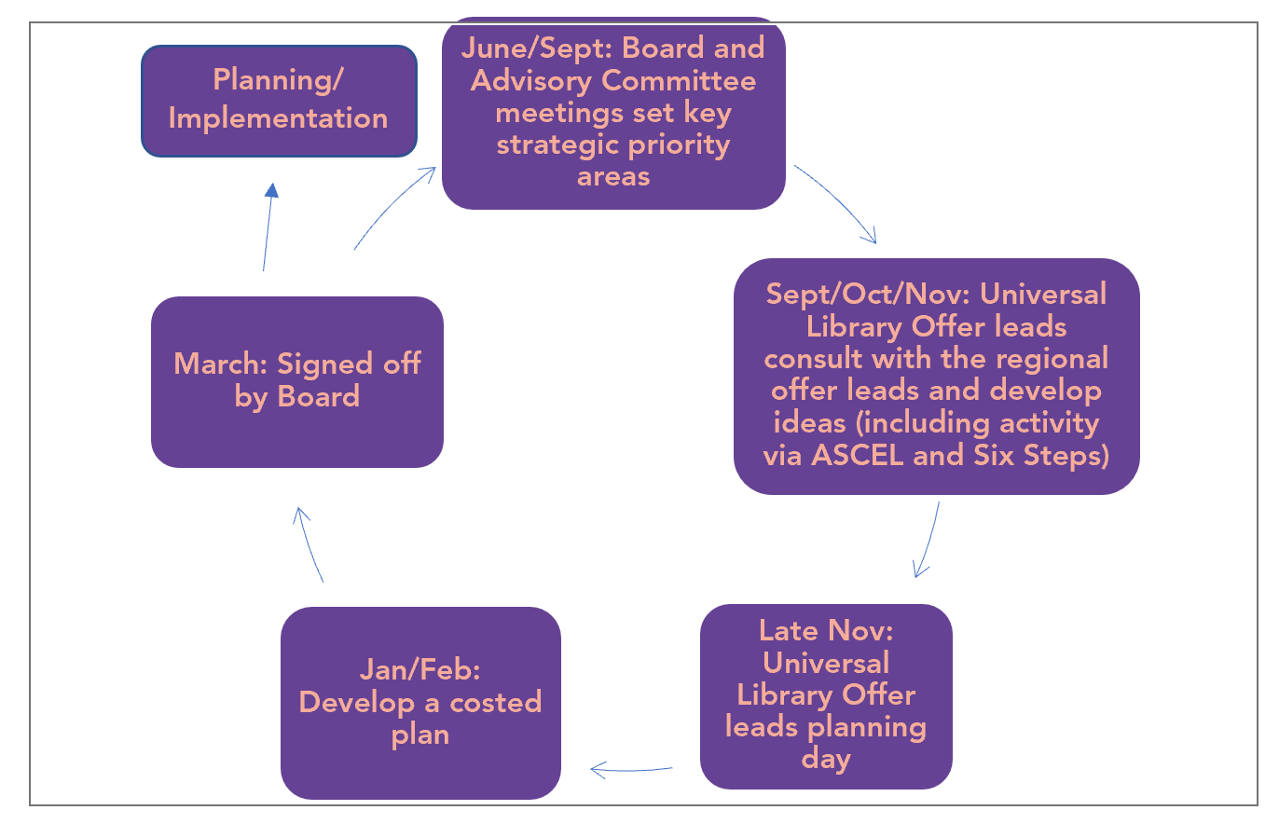

They are supported by two partner ‘promises’ The Children’s Promise and The Vision and Print Impaired People’s Promise

The Children’s Promise is delivered by ASCEL (The Association of Senior Children’s and Education Librarians) https://ascel.org.uk/

ASCEL is the national network of senior managers in Children’s Public and Schools Library Services, leading for excellence in library services for children and young people and schools so that every child and young person visiting a public library should be inspired by an exciting environment which makes reading for pleasure irresistible, and every school has access to a high-quality school library service.

The Vision and Print Impaired People’s Promise delivered by Share The Vision
www.readingsight.org.uk

Share the Vision is a coalition of UK organisations that work together to improve the quality, availability and accessibility of library services for visually impaired and print disabled people. Our partners include ASCEL, the British Library, Calibre Audio Library, ClearVision, Libraries Connected, and RNIB.

Share The Vision oversees the Reading Sight website, which is a bank of resources to support anyone with an interest in helping people with sight loss to access reading and reading services; and the Vision and Print Impaired People’s Promise, as part of the Universal Offers framework (http://www.librariesconnected.org.uk/universal-offers/vision-print-impaired-peoples-promise)

Main functions of the role
To support the development and delivery of the Universal Offer annual plan including developing clear costings and success criteria.
- To steer the annual planning cycle, in collaboration with the Universal library Offer networks and reporting to Libraries Connected’s Advisory Committee and the Board of Trustees
- To maintain an overview of the annual plan ensuring it is delivered as an integrated programme.
- To ensure projects are evaluated.
- To compile reports to demonstrate the extent and impact of the offer.
- To convene and manage offer meetings.
- To support and co-ordinate the development and possible delivery of some projects
- To contribute to bid development.
- To liaise with partners and Universal Library Offer leads.
- To create advocacy and information content for members and stakeholders as required.
- To deliver presentations about the offers to library staff and partners.
- To support Share The Vision in the development and delivery of the action plan surrounding the Vision and Print Impaired People’s Promise.

Key relationships:
- Line managed by Libraries Connected’s Programme Manager
- Reports to Libraries Connected’s Advisory Committee and Board
- Works as part of the core Libraries Connected Team.
- Works with public library heads of Service who are national Universal Library Offer Leads.
- Works with partners and stakeholders e.g. The Reading Agency and Arts Council England.
- Works with Communications Team to ensure Universal Library Offers are reflected in communications.
- Works with the Chair of Share The Vision and Board members/partner organisations.

About You - Person specification

Experience
Essential:
- Experience of co-ordinating programmes with dispersed delivery teams, and ensuring they are effectively delivered, in line with KPIs.
- Experience of working with partners and developing effective working. relationships that are focused on problem solving and resolving issues swiftly.
- Experience of managing regular project reporting and monitoring programmes.
- Experience of writing concise reports and compiling issues logs.
- Delivering presentations

Knowledge/ Qualifications
Essential:
- Excellent organisational skills, with a keen attention to detail.
- Excellent communication skills and ability to build consensus among a varied group of stakeholders.
- Experience of supporting funding bids
Desirable:
- Knowledge of the public sector and its customer service ethos.
- Understanding of the modern public library service sector.

Behaviours/ Competencies

- Equality and diversity:
Ensure inclusion is embedded within all working practices
- Communicating and relationship building:
Excellent verbal and written communication skills; able to build effective working relationships across a diverse group of stakeholders.
- Project coordination:
Takes a highly organised yet pragmatic approach to project coordination, always focused on solutions and problem solving.
- Teamworking:
Takes a collaborative and open approach to working with others, actively participating in team meetings, works flexibly on projects with other team members.
- Results orientation:
Works effectively under pressure to meet deadlines, able to manage own workload and set own priorities.
- Planning and organising:
Ability to manage multiple strands of work, effectively prioritising activities.
- Problem solving and decision making:
Strong observational and analytical skills, including ability to make recommendations for process improvement.
- Customer service ethos:
Able to demonstrate strong commitment to delivering good customer service.

Professional skills

- Excellent project management skills
- Confident user of MS Office Tools, especially Word, Excel and PowerPoint
- Confident use of Basecamp (or equivalent) as the project communication platform.
- Research and analytical skills, including gathering evidence and compiling brief reports and reviews.
- Ability to use online conferencing facilities.

Circumstances
- Travel within the UK may be required.
- This role can be home-based. The post holder may need to spend some time in the office (Currently based in Islington, London).
- It is possible to negotiate flexible working across the week.

How to apply

- Please email your CV and a covering letter, setting out relevant experience and how you fit the person specification in this role description to info@librariesconnected.org.uk by 5pm on Thursday 27 May 2021
- Interviews will be held on Tuesday 8 June 2021

Working Hours: Standard working hours are 37.5 per week, and a standard work pattern of 9 am to 5.30 pm with an hour for lunch. For this role, flexible working arrangements are possible if agreed in advance, with core hours of 10 am to 12 noon, and 2 pm to 4 pm.

Holidays: 25 days per year (for full time roles). Libraries Connected reserves the right to nominate up to four days between Christmas Day and New Year’s Day as designated holidays which employees are required to take from their holiday entitlement. Carry over of holiday from one holiday year to the next is only allowed in exceptional circumstances and if agreed well in advance.

Pension: Employees will be auto enrolled in an approved pension scheme that is managed under a Pension Master Trust arrangement. Libraries Connected will contribute 5% of qualifying earnings and match employee contributions of 5%.

Sick Pay: Arrangements for payment during periods of sickness absence are as follows:
- 0 – 6 months service: Statutory Sick Pay only
- 6 months to 2 years’ service: 4 weeks full pay
- 2 years to 5 years ‘service: 4 weeks full pay & 4 weeks half pay.
- More than 5 years’ service: 8 weeks full pay & 8 weeks half pay.

